

Adama Science and Technology University School of Electrical Engineering and Computing Department of Computer Science and Engineering



A FINAL PROJECT SUBMITTED FOR THE FULLFILMENT OF BACHELOR OF SCIENCE DEGREE IN COMPUTER SCIENCE AND ENGINEERING

TITLE: ONLINE auction system for astu

**Name**

1. Adinan Mohammed A/ur4805/09

2. Besufekad Sintayehu A/ur5054/09

3. Edomias Tesfaye A/ur5074/09

4. Ekram Kumdin A/ur4775/09

5. Mikiyas Leul A/ur4515/09

Advisor: Ms. Lomi D. (MSc)

August 24/2021, Adama

**Approval**

Name ID NO Signature

1. Adinan Mohammed A/ur4805/09
2. Besufekad Sintayehu A/ur5054/09
3. Edomias Tesfaye A/ur5074/09
4. Ekram Kumdin A/ur4775/09
5. Mikiyas Leul A/ur4515/09

Approved by

Advisor: Ms. Lomi D. (MSc)

Signature: ____________

**Acknowledgement**

We would like to express our gratitude for Adama Science and Technology University for creating a peaceful learning environment that allowed us to work on the project. Also, for ASTU purchase and property administer directorate for their help on providing the necessary documents for our project. We also would like to thank our project adviser Ms. Lomi for the advice, constructive comment and support she has given us in the making of the project. Furthermore, we would like to thank all parties that have assisted us along the way.

The Team Members

Table of Contents

Chapter 1 1

1.Introduction 1

1.2. Background of the organization 1

1.3 Background of the project 1

1.4 Statement of the problem 2

1.5 Purpose of the project 2

1.6 Objective of the project 3

1.6.1 General objective 3

1.6.2 Specific objective 3

1.7 Scope and limitation 3

1.7.1 Scope of the study 3

1.7.2 Limitation of the project 3

1.8 Feasibility study 4

1.8.1 Technical feasibility 4

1.8.2 Operational feasibility 4

1.8.3 Economic feasibility 4

1.9 Significance of the project 4

Significance of the project- 4

1.10 Beneficiaries of the project 5

1.11 Methodology 5

1.12 Development tools 6

1.13 Required resources with the cost 7

1.14 Task and Schedule 7

1.15. Team Composition 8

Chapter 2 9

2. Description of Existing system 9

2.1 Major Function of Existing system 12

2.2 Users of the current system 13

2.3 Drawback of the current system 13

2.4. Business rules 14

Chapter 3 15

3. Proposed System 15

3.1 Overview 15

3.2 Functional requirement 15

3.3 Non-functional requirement 15

3.4 System model 17

3.4.1 Scenario 17

3.4.2 Use case model 22

3.5 Object Model 35

3.5.1 Data Dictionary 35

3.5.2 Class Diagram 38

3.6 Dynamic Model 39

3.6.1 Sequence Diagram 39

3.6.2 Activity Diagram 43

3.6.3 State Chart Diagram 47

Chapter 4 50

4. System design 50

4.1 Overview of system design 50

4.1.1 Purpose of the system design 50

4.1.2 Design goal 50

4.2 Proposed system architecture 52

4.2.1 System process 53

4.2.2 Subsystem decomposition 55

4.2.3 Hardware/ software mapping 55

4.2.4 Persistent data management 56

4.2.5 Component diagram 61

4.2.6 Database design 62

4.2.7 Access control 63

4.2.8 User interface design 64

Chapter 5 67

5. Implementation 67

5.1 Overview 67

5.2 Coding Standard 67

5.3 Prototype 68

5.4 implementation detail 69

5.4.1 Client-side 69

5.4.2 Server-side 69

5.5 Deployment 69

Chapter 6 72

System Testing 72

6.1 Objective 72

6.2 Scope 72

6.3 Resource 72

6.4 Role 72

6.5 System 73

6.6 Schedule 74

6.7 Test Case Scenarios and Requirement 74

1. Data and Database Integrity Testing 74

2. Functional Testing 74

3. User Interface Testing 75

4. Load Testing 75

5. Security and Access Testing 75

6.8 Test strategy 75

1. Data and Database Integrity 75

2. Function Testing 76

3. User Interface Testing 76

4. Security and Access Testing 77

6.9 Estimated risk 78

6.10 Contingency plan 78

Chapter 7 79

User Manual 79

1. Home page 79

2. Login 80

3. Subscription 80

4. Main page 81

5. Request 82

6. Advertisement 83

7. Profile 83

8. User Registration 84

9. Proforma-Purchase 85

10. Bid Management 88

11. Received request for approval 89

12. Approved Request 90

13.File Management 90

Chapter 8 92

8.1 Conclusion 92

8.2 Recommendation 92

Reference 93

**Tables**

Table 1 Development tools 6

Table 2 Required resources with the cost 7

Table 3 Task and schedule 7

Table 4 Team Composition 8

Table 5 Use case description for login 26

Table 6 Use case description for Purchase Request 26

Table 7 Use case description for Register 27

Table 8 Use case description for Approve purchase request 28

Table 9 Use case description for Dis-approve purchase request 28

Table 10 Use case description for Subscription 29

Table 11 Use case description for Quality grading 29

Table 12 Use case description for Make crud operation 30

Table 13 Use case description for Payment 30

Table 14 Use case description for Grant bid access 31

Table 15 Use case description for logout 31

Table 16 Use case description for Prepare bid document 31

Table 17 Use case description for post-bid document 32

Table 18 Use case description for fill form in make advertisement 32

Table 19 Use case description for Post advertisement in make advertisement 33

Table 20 Use case description for view advertisement 33

Table 21 Use case description for View bid announcement 34

Table 22 Use case description for Make bid 34

Table 23 Data Dictionary 35

Table 24 Deployment diagram 70

Table 25 Testing scope 72

Table 26 Testing role 72

Table 27 Systems of testing 73

Table 28 Schedule for system testing 74

Table 29 Data and database integrating 75

Table 30 Functional testing 76

Table 31 User interface testing 76

Table 32 Security and access testing 77

**Table of figures**

Figure 1Use case diagrams 25

Figure 2 Class diagram 38

Figure 3 Requisition sequence diagram 39

Figure 4 Advertisement sequence diagram 40

Figure 5 Make bid document sequence diagram 41

Figure 6 Post bid document 42

Figure 7 Login activity diagram 43

Figure 8 Purchase request activity diagram 44

Figure 9 Registration activity diagram 45

Figure 10 Make advertisement activity diagram 46

Figure 11 Requisition state chart diagram 47

Figure 12 Advertisement state chart diagram 48

Figure 13 Subscription state chart diagram 49

Figure 14 View purchase request system process diagram 53

Figure 15 Subscription system process diagram 54

Figure 16 Complete system process diagram 54

Figure 17 Subsystem decomposition diagram 55

Figure 18 Hardware/software mapping diagram 56

Figure 19 Persistent data management diagram 56

Figure 20 Component diagram 61

Figure 21 Database design diagram 62

Figure 22 User interface Login 65

Figure 23 User Interface Advertisement 65

Figure 24 User interface Bidders 66

Figure 25 Sample code from project 70

Figure 26 User manual home page 79

Figure 27 User manual login 80

Figure 28 User manual Subscription 80

Figure 29 User manual main-page 81

Figure 30 User manual request 82

Figure 31 User manual advertisement 83

Figure 32 User manual profile 83

Figure 33 User manual user-registration 84

Figure 34 User manual proforma-purchase 86

Figure 35 User manual Bid document 87

Figure 36 User manual bid management 88

Figure 37 User manual bid report 89

Figure 38 User manual for request approve/decline 89

Figure 39 Approved request 90

Figure 40 File management 90

**Acronyms**

ASTU Adama science and technology university

MS word Microsoft word

HTML Hypertext Markup Language

CSS Cascading Style Sheets

IT Information technology

SQL Structured Query Language

Vs code Visual studio code

PPAD property and purchase administer directorate

CPT central procurement team

**The softcopy of this documentation for the Online Auction System for ASTU found on our organization GitHub repository:**

[**https://github.com/GC-project-ASTU/Online-Auction-System-For-ASTU**](https://github.com/GC-project-ASTU/Online-Auction-System-For-ASTU)

# Chapter 1

# 1.Introduction

Bidding is a way of buying and selling goods or services through a tender or auction. The bid awarded to the bidder when purchasing with a minimal price based on the provided quality. Moreover, an Auction in the event of a sale where potential buyers place competitive bids on assets or services in an open or closed format. Auctions are the way buyers and sellers believe they will get a good deal buying or selling assets.

Every country has rules, regulations, and establishing procedures, in ASTU there is FEDERAL GOVERNMENT MANUAL FOR PURCHASING IMPLEMENTATION. This manual governs the organization and details in the bid organized according to this Manual. However, the process undertaken by the organization accomplishes manually from the starting of the bidding and purchasing action to the final part of the process, here is the concern that arises many issues. The different Equipment and supplies, which are in or out from the university are all managed based on the manual work.

The online auction system refers to the bidding process means the digitalization and automation of the bidding process from the low level of paperwork to the final level of contract closure in a very efficient and effective way of implementation.

**How Auctions Work**

There are two formats of bidding which are an open format and closed format in an open format all bidders are aware of the bids submitted. In a closed format, bidders are not aware of other bids. Auctions can be live or they can be conducted on an online platform. The asset or service in question is sold to the party that places the highest bid in an open auction and usually to the highest bidder in a closed auction.

# 1.2. Background of the organization

Adama Science and Technology University (ASTU) was first established in 1993 as Nazrete Technical College, offering degree and diploma level education in technology fields. Later the institution was renamed Nazrete college of Technical Teachers Education then changed to Adama University. After chosen by the Ministry of Education in 2008 it was opened with the various program in applied science and engineering fields also, the organization changes its name to Adama Science and Technology University.

ASTU Purchasing and property administration Directorate was established in 1993 with the establishment of ASTU to satisfy the various needs of the university by purchasing different types of tools, items, and other services by classifying itself into the main department of Bidding and Purchasing.

# 1.3 Background of the project

The main concern of this project is to study the current bidding system and develop a system that operates digitally which is online, the system of purchasing and bidding which is widely used in current times is operated manually. Most organizations conduct bidding without any type of IT-supported bidding system. The problem with the current bidding system is bidders must attend specific places otherwise; they cannot participate in the bidding process. An online Auction system avoids problems that both bidders and organizations might face due to the types of problems mentioned above and we believe this system (Online auction system) will make the bidding process easier, efficient, timesaving, and reliable for both buyers and sellers.

# 1.4 Statement of the problem

Lack of digitalization systems leads to unnecessary time wastage, Data redundancy, limitations of availability, and a major reason for the wastage of external cost on the process of implementations.

The existing Auction system in Adama Science and Technology University follows a traditional way of mechanism for the process of bidding and purchasing. The process undertaken by the organization accomplishes manually from the starting of the bidding action to the final part of the process, here is the concern that arises many issues:

* Time management problem
* Wastage of materials (resources)
* leading to external cost for promotion(advertisement)
* Data redundancy due to manual process
* Limitations of participants
* leading the bidder for external cost
* Transparency issues

Therefore, This Online Auction system would be able to overcome the above problems by making the traditional process digital and automated from the low level of paperwork to the final level of contract closure in a very efficient and effective way of implementation.

# 1.5 Purpose of the project

The purpose of this project is to overcome the problems of the existing purchasing and bidding system by changing the complete current system of ASTU purchase and property administer directorate manual works into a computerized or online system without affecting the structure of the existing system.

**From the university perspective:**

* The system brings out a mechanism of digitalized and automated implementation of processes that makes the purchasing and auction system more transparent and organized.
* It would be a good way to obtain the best financial return for ASTU.

**From the bidder perspective:**

* It brings free and fair competition between bidders.

# 1.6 Objective of the project

## 1.6.1 General objective

Design and develop an Auction System for ASTU Purchase and Property Administer Directorate.

## 1.6.2 Specific objective

To achieve the general objective, we have to surpass the following:

* Study the given problem from different perspectives. (How ASTU purchase and property administer directorate work)
* Gather any data and information that would be an input to the project as if how supplies and equipment requests made and how purchasing occur as well as bidding perform.
* Decide on a general direction and principle to follow throughout the analysis, design, and development phase.
* Implement the system based on the proposed design and architecture.
* Develop prototypes as early as possible
* Test prototype of the new system rigorously and arrive at a stable working software version.

# 1.7 Scope and limitation

## 1.7.1 Scope of the study

* Support different requests for supplies and equipment from the major division of service seekers like departments, ASTU directorates.
* Support Pro-forma-based purchasing (the purchasing mechanism which not includes bidding and advertisement)
* Support auction (on the required criteria of ASTU purchase and property administer directorate for different approved requests)
* Advertisement for the bid.

## 1.7.2 Limitation of the project

* The system may not fulfill the gap (not completely resolve all manual works)
* Quality inspection. (Quality inspection of proposed products for evaluation of bidders will be performed manually)
* Time constraint (limitation of time for the project)

# 1.8 Feasibility study

A feasibility study is a crucial thing to evaluate the cost and benefit of the new system whether the system is doable and profitable. Because of the feasibility study, the decision will take whether a specific action makes sense from an economic and operational standpoint.

## 1.8.1 Technical feasibility

The team members expect the system to be technically feasible. The system will be developed using different open-source, easily available software. The team members try to understand what the project needs and through refereeing different online courses and available documentations, they would try to design and develop the system. To bring out the technical feasibility of the project as well as to utilize any open-source development methods team members use a laptop, lab computers, and open-source software like slack, Git-hub, Telegram, MS word, Enterprise Architecture, Phpstorm, Vs-code, Browsers, PHP MyAdmin, CSS, Bootstrap, Native PHP, Node-JS and Data-bases (relational data base SQL) and firebase-database.

## 1.8.2 Operational feasibility

Once the system is deployed and available for any potential customer and it starts to give its service, it would be very helpful for solving any of the major concerns. However, the service is beyond that because it addresses the major issues of transparency between both sides of Auction participants. As a system, it requires regular monitor and control to make sure that any of the available data performed and to monitor any of the service requests.

## 1.8.3 Economic feasibility

The system as a product would be beneficial in many ways. One of the major cost benefits is a good financial return for ASTU also; it reduces unnecessary costs, which will spend on the promotion and advertising of the bidding, paperwork, and employers' salary. With some kind of agreement with the ASTU, the system could be developing as a main online Auction and purchasing system to replace the traditional work so it would result from an economic income to the developers.

# 1.9 Significance of the project

# Significance of the project-

* Effective management of request and approval for a bid
* Simplicity for the bidders to supply the requested document and to be an active participant in the bidding process.
* Effective and accountable way of bidding
* Protection over the documents
* Better and fast process scheduling
* Reducing errors
* Reduction of cost
* Improved efficiency of employees
* Better and faster decision making

# 1.10 Beneficiaries of the project

* The first beneficiary of this project is ASTU Purchase and property administer directorate and the others are Adama Science and Technology University (ASTU) and different bidders all over the country.

# 1.11 Methodology

Data collection methodology:

* **Document Analysis:**

We have analyzed a document that was placed in ASTU Purchase and property administers Directorate by comparing each business rule and process. We used information from the document.

* **Observation:**

We visited ASTU Purchase and property administer Directorate Office and observe how the bidding under taken.

* **Interview:**

At the time we visit, ASTU Purchase and property administer Directorate office to understand how their system work. Then we interview two employees of the office and the Director

Mr. Kuma Waqtolla

MR Kuma Waqtolla is the Directorate Director of ASTU Purchase and property administers Directorate office. He gives us basic information about the system and permits us to find out all information from his subordinate.

Mrs. Aberash

Mrs. Aberash is the head of the central procurement office of ASTU Purchase, property administers Directorate, and she told us how they purchase items and the whole system about purchasing.

Mr. Yoseph

MR Yoseph is the Head of the bidding management office. He told us all information about the bidding process.

**System development methodology**

We planned to use agile because collaboration is highly important for the success of the project.

* Agile focuses on active software rather than documentation.
* It offers direct communication that helps in maintaining transparency.
* It also helps us to deliver working software with a preference for the shorter timescale.
* Also promotes the teams to meet several days a week to discuss progress, identify problems and plan the day’s activities to be able to produce working software as quickly as possible.

# 1.12 Development tools

**Hardware tools:**

* Computer
* Storage (hard-disk /flash)

**Software tools:**

Table 1 Development tools

|  |  |
| --- | --- |
| Tools or Programs | Used for |
| Slack, Git-hub, Telegram | Group working platform |
| MS Word | For preparing and compiling the document |
| Enterprise Architect | As a Designing tool for different UML diagrams. |
| Phpstorm, Visual studio code | Used as an editor for the code |
| Browser | To open the system and display web application |
| SQL | A database that we use to manage and Store our Data. |
| CSS, Bootstrap, Node-JS | A language used to develop front-end |
| Native PHP | The language used to develop the back-end of the system |

# 1.13 Required resources with the cost

Table 2 Required resources with the cost

|  |  |  |  |
| --- | --- | --- | --- |
| Material name | No. material | Price in ETB | Total price in ETB |
| Lap top 1 | 1 | 25000 | 25000 |
| Flash 8GB | 1 | 250 | 250 |
| Paper | 100 | 0.50 | 50 |
| Pen | 5 | 10 | 50 |
| Binding | 2 | 10 | 20 |
| Print | 110 | 1 | 110 |
| Miscellaneous cost | - | 300 | 300 |
| The total cost of material |  |  | 25,780 |

# 1.14 Task and Schedule

Table 3 Task and schedule

|  |  |  |  |  |  |  |
| --- | --- | --- | --- | --- | --- | --- |
| Phases | Time frame | | | | | |
| March 01,2021 | March 15,2021 | April 25,2021 | May 5,2021 | July 1,2021 | Aug 13,2021 |
| Project start | **✓** |  |  |  |  |  |
| Requirement gathering and Analysis | **✓** | **✓** |  |  |  |  |
| Documentation |  | **✓** | **✓** | **✓** |  |  |
| Design the Prototype |  |  | **✓** | **✓** |  |  |
| Implementation |  |  | **✓** | **✓** | **✓** | **✓** |
| Testing phase |  |  |  |  | **✓** | **✓** |
| Finalizing project |  |  |  |  |  | **✓** |

# 1.15. Team Composition

Table 4 Team Composition

|  |  |  |  |
| --- | --- | --- | --- |
| **Title** | **Online Auction System for ASTU** | | |
| Team  Composition | Name | Email | Roll |
| Edomias Tesfaye | [edomwt@gmail.com](mailto:edomwt@gmail.com) | Front-end development and Documentation |
| Besufekad Sentayehu | Besufekadsintayehu42@gmail.com | Requirement analysis, Back -end development, Documentation |
| Ekram Kumdin | bintkumdin@gmail .com | Front-end Development and Documentation |
| Adnan Mohamed | adunimh@gmail.com | Ui/Ux design, Requirement analysis, and Documentation |
|  | Mikiyas Leul | mikiyasleul@gmail.com | Coordinator, Back-end development and Documentation |

# Chapter 2

# 2. Description of Existing system

Large organizations, especially governmental institutions, and agencies have a particular process when procuring and purchasing different supplies and equipment. Likewise, Adama Science and Technology University (ASTU), in certain, has a purchasing and bidding system to procure the required items and services. All those works are under the responsibility of ASTU Purchase and property administer Directorate. Under these directorates, there are subdivisions like central procurement, bid committee, quality checkers...etc.

**Request process.**

The different directorates (34 directorates) make a request on the required materials and services to the ASTU purchase and property administer directorate.

The requests are made through sending a sealed file which contains a detail description about the request materials, data, directorate name, and other necessary information’s. once the necessary document prepared and compiled it will be sent to the directorate.

**The existing system has two main parts in order to give a response to the approved request:**

1. The first one is the open bidding process.

This purchasing mechanism has 22 steps and is classifies into two. The first one is a bidding process that requires a quality assessment and the second one that does not require a quality assessment.

* Open bidding process which requires quality assessment

The purchasing of any materials under this category requires quality assessment. The bidding computation will depend on the value of the quality grading and the price bidder submit for the specific product. Therefore, by considering both the value of quality and the proposed prices, the winners are select, and further steps will go on.

* Open bidding process which does not require quality assessment

This open bidding process does not require quality assessment but the bidding computation is made only using comparing the price bidders proposed.

**Steps for open bidding process:**

1. Bid documents will be prepared.

2. The Procurement Approval Committee shall review and approve the bid document.

3. Bid announcement will be prepared.

4. Request for payment of bid service forwarded to the Finance and Budget Directorate.

5. Purchaser Pay for Ethiopian Press Agency by check.

6. The Ethiopian Purchasing Agency will publish the advertisement in the Addis Zemen newspaper or Herald newspaper.

7. Bid documents will be sold to the bidders within 15 days.

8. Bids will be opened on the 16th day.

Bid documents will be opened on the 21st day.

The bid document will be opened on the 4th day (International Bid)

9. The bid opening ceremony will be signed.

10. Bidding documents shall be submitted to the University Procurement Development Committee with a technical evaluation result.

11. Financial evaluation or technical evaluation results will be sent to the University Procurement Approval Committee.

12. The Procurement Advocacy Committee shall evaluate and approve the decision and submit its decision to the Procurement and Property Administer Directorate.

13. The Procurement and Property Administer Directorate informs (announce) the bidders of the financial evaluation.

14. The financial bid winners will sign the contract by providing the required document within seven working days.

15. Submission to the University Property Administer Directorate shall be made within the given days after signing the contract.

16. After technical evaluation the bid document will be opened after seven (7) working days.

17. The bid opening ceremony will be signed (central procurement)

18. A review of the financial bid document shall be submitted to the Procurement Approval Committee.

19. Procurement Approval Committee shall review and approve the document.

20. Notify the approved documents to the Procurement and Property Administer Directorate.

21. Purchase and Property Administer Directorate shall inform the bidders of its financial results.

22. Then the provisions of verses 14 and 15 shall apply.

1. The second one is Pro-forma invoice purchasing

This purchasing mechanism has 24 steps to make it fully implemented.

**Steps for Pro-forma invoice purchasing process:**

1. The secretary of the purchasing department directorate will accept purchase requests sent from different directorates, after signing.

2. The secretary will deliver the letter of a purchase request to the director.

3. The director will direct the letter of request to the central purchasing team.

4. The central purchasing team will accept the letter after the secretary of the director write down the date and the number of the request letter, this letter of request will be delivered to the head of the central purchasing team.

5. The head of the central purchasing team will pass a directive to prepare a Pro-forma invoice format to the central purchase secretary.

6. The team of the central purchase will prepare the format as requested and deliver it to the head to have it signed.

7. The signed letter will be passed to the purchasing team. /Purchasing department

8. The purchasing department will put in a request to the department of transportation /Logistics/ to be supplied with vehicles to gather a Pro-forma invoice.

9. After the request for transportation has been issued, the team will travel to Addis Ababa or within Adama to gather the invoice and deliver it to the purchasing department Directorate director.

10. The director will authorize the sealed envelopes and send them to the central purchasing team via a secretary.

11. The central purchase team will gather purchase experts and open the sealed envelope after signing the envelope.

12. The Pro-forma invoice will be passed to the purchase evaluation team.

13. The evaluation team will review the legal documents and rank the contenders in a table and choose the one with the lowest price as a winner. Prepare a minute with the team that opened the Pro-forma and sign the paper. After that, it will be delivered to the director.

14. After the director reviews the legitimacy of the evaluation and checking the signature, the request will be issued and approved to make a purchase.

15. The secretary of the director will titter each signature and delivery it to the registry.

16. After the registry revise the number of copies needed and other requirements, the letter will be given the registration number and issued date. This will be delivered to the finance and budget directorate to be authorized.

17. The finance and budget directorate will pass directives to the finance officers to prepare payment, after revising the documents.

18. The finance officers will review the balance, and prepare a check and deliver it to the finance and budget directorate.

19. The responsible directorates will sign the check and pass it to the purchaser.

20. The purchaser will cash out the check-in at the nearby bank and buy the requested item.

21. The requested item will be delivered to the storage facility.

22. The department that requested the purchase would inspect and sign the inspection form, the purchaser will receive model 19.

23. The department that requested the purchase will be able to use the purchased item.

24. The purchaser will make model 19 and other related documents. These documents will be delivered to the finance and budget directorate to balance per request and purchase /financial statement.

**Advertisement:**

The directorate makes an advertisement for the bid, through printed media and online mediums. ASTU uses Negairit Magazine and its own two official websites. The directorate announces the bid and any purchasing-related advertisement using those public mediums.

The directorate make all those works like request acceptance, advertisement, bid computation, quality assessment, contract closure, financing by following the existing manuals which rely on the FEDERAL GOVERNMENT MANUAL FOR PURCHASING IMPLEMENTATION

# 2.1 Major Function of Existing system

As there is a manual-based working system to the ASTU purchase and property administer directorate, the major functions are:

* Request management
* Pro-forma-based purchasing
* Open bid process (for national and international bidders)
* Big computation (The bid computation depends on the type of bid, price and quality of products proposed by the bidders are the core values used for evaluation of bidders.)
* Resource management (different supplies and equipment)
* Advertisement (Through Negairit magazine and using ASTU official websites)

# 2.2 Users of the current system

The actors involved in the current system are -

1. ASTU purchase and property administer directorate

* The main directorate which responsible for the whole process.

2. Service seeker:

* The different directorates (34 directorates) available in ASTU.

3. Casher

* Accept the payment of bidders and purchasers.

4. Bidder

* They are major participants in the bidding process.

5. Advertiser

* The one, who is responsible for the advertisement of bid and different purchasing advert.

6. Bid committee

* The central office is responsible for controlling the whole process of auctions.

# 2.3 Drawback of the current system

The current system has the following drawbacks:

* The process is time and resource-consuming

The manual way of doing the work makes the procurement and purchasing of the process to be time and resource consuming. The entire request, which comes from 34 different directorates to the ASTU purchase and property administer directorate passes through different stages of permission and validation through manual work.

* Manual file arranging system

At the different stage of the work the request, permission, validation, bidder’s comparison table (based on the price they submit for a specific product), financial statement, quality assessment, and lots of papers work attached for one purchased material makes the file management work to be bulky and huge. In addition, they used traditional ways of file storage and management.

* The bidders go through a lot to get what they want

Bidders’ connection and the time, which needs by ASTU purchase and property administer directorates for checking the different files, for validation, financial work, the price, and quality assessment, comparing different valid candidates based on the preform they submit makes bidders go through a lot to get what they want.

* Safety and security issues

Most manual-based works have safety and security problems like paper loss, unexpected file damage, stealing, loss of confidential information.

Loss of confidential information is one of the major concerns in securing the process of purchasing and auctions. So, on the current system, there are still issues and complains related to security issues and the confidentiality of the system is still not solved.

* Most users make complaints in improper ways. It makes workers on this department dis-comfortable

ASTU has a directorate on different hierarchies to accept complaints from students, different division workers, outside persons that have direct and indirect contact with the organization. Likewise, all users should use this protocol if they have any complaints related to the service that they get from ASTU purchase and property administer directorates. Nevertheless, most of the time customers improperly make their complaints and aggressiveness. This makes workers in this division to be dis-comfortable.

# 2.4. Business rules

The following are the business rules of the system.

1. The Bid committee is the only team allowed to manage any activity related to the Bid submission and revealing the winner.
2. The Bidder must be authenticated by a means of payment to access the system.
3. Bidder must be registered before any operations related to bids are performed.
4. The bid is generated if and only if a specific bid request and bid verification are already satisfied.
5. The director will sign on all sealed proforma envelopes and authorize them after they are collected and submitted.
6. The sealed envelopes will open after the bid committee gather purchase experts and make signing.
7. If the service seeker wants to request a service, he/she should send a request to the Bid Committee.
8. Bid committee view and manages all things about Bid.
9. Only Bid Committee can manage and modify the time adjustment.
10. Bidder has the privilege of viewing an advertisement.
11. Bidders should get the full information of bid-report (The winner/ wining-price/ different bidder rank).
12. The Bid committee orders advertisement on services and products that are approved, issued by service seekers.
13. The bid committee must verify any service and product that are issued by service seekers.
14. The system should compare and reveal the bid winner.

# Chapter 3

# 3. Proposed System

# 3.1 Overview

The proposed system aims to develop a web-based platform that will provide computerized and digitalized ways of doing the current manual works of ASTU purchase and property administer directorate. The system will perform major functions of the existing manual works, but it will not include some of the manual tasks, which need human interventions for quality checking and validation of proper documentation. Our system includes request forms, advertisement of different bidding and Pro-forma purchase, ranking of bidders based on price and quality grade, subscriptions of bidders using legal documents, announcement and report generations, bid computation, and storing confidential and proper documents.

The proposed system will be advantageous in terms of timesaving, security, and good financial returns for the organization it will solve the reliability problems of the existing manual works.

This chapter portrays the projects from aspects of Requirement Engineering, Architecture of solution including general architecture, requirement elicitation and specification, components diagram, class diagram, data model, and functionality of requirements.

# 3.2 Functional requirement

* Requisition platform (a platform that supports service seekers to the system)
* Request approval and disproval
* Subscription module (for validation of legal bidders)
* Catalog (form) generation
* Crud operation (Add, Update, and Delete forms)
* Advertisement platform (for any open bid and other required purchasing issues)
* Proforma management. (a platform the support all proforma based process)
* Solicitation (response) for catalog.
* Compute the Bid. (The system by itself makes a bid computation)
* Winner announcement. (Announcement after the bid computation is complete and the time for the announcement is meet.)
* File management. (All required and confidential data for a specific purchase compiled and stored together).
* Payment integration.

# 3.3 Non-functional requirement

**User interface**

* The user interface should support optional ways to complete a task.
* The interface should be attractive and user-friendly.
* Minimum response time for the displayed required interface.
* having graphical ways of error message displaying
* The system will have a clear content presentation.
* Implementing an easy navigation method.
* Strategical use of color and texture throughout the entire system.
* Providing helpful information and a user-centric approach.

**Authentication**

* Depending on the type of the user, the system will give different access.
* The system supports the admin user name and password to have full access to the system.
* Giving different privileges to protect intruding.

**Usability**

* Through provides easy access, with an easy user interface.
* The system shall be easy to understand and easy to implement.
* The system will ensure the increased performance of users completing their tasks through evaluating the easiness of the system.
* The information and tools within the system are made to be easily accessible and easily understandable.
* Implements a safe environment for the things that can be undone.

**Reliability:**

Our system should be reliable through:

* Appropriate error messages will be provided to users whenever incorrect information is inserted.
* Setup error handling methods in a place were in case of exception
* The platform works with slow network connections.

**Compatibility**

* The system will be compatible with existing operating systems and different browsers.

**Security**

* The system should not display or give access to confidential data that are not meant to be displayed before the predefined date and time.
* The sealed-bid auction method is used for the system confidentiality and privacy.

Various sealing function may be used to seal the bids and keep them secrete before their opened.

Four phased (Preparation phase, the bid submission phase, bid opening phase, winner determination phase)

Techniques for sealing function is:

1. Sealing by hash-function
2. Sealing by encryption

* MD5 encryption (message digest algorithm 5) for password encryption on the database.

# 3.4 System model

## 3.4.1 Scenario

**1. Scenario Name:** Browse Website

**Actors:** All user

**Entry Condition:**

* Power supply has to be available to power on the laptop.
* Internet connection has to be available.

**The flow of events:**

* Users open a web browser application on the computer.
* Types in the address of the website and search it on the web.
* Once, the website loads successfully he/she browses the site for what they are looking for.

**2. Scenario name:** purchase request

**Actor:** Requisitioner

**Entry Condition:**

* Power supply has to be available to power on the laptop.
* Internet connection has to be available.
* They have to navigate to the website.
* The user has a valid user name and password which is recognized by the system.

**The flow of event:**

* The system displays the homepage.
* The user chooses the request form tab.
* Requisitioner fills request form.
* Submits its request.
* The system displays a Successful message.

**Alternate condition:**

* If the user fills the form incorrectly, the system will generate an error message.

**3. Scenario name:** Approve/Dis-approve

**Actor:** PPAD

**Entry Condition:**

* Power supply has to be available to power on the laptop.
* Internet connection has to be available.
* They have to navigate to the website.
* The user has a valid user name and password which is recognized by the system.
* A submitted request by Requisitioner.

**The flow of event:**

* The system displays the homepage.
* The director chooses the requested services tab.
* The director either approves or disapproves the requested service.

**4. Scenario name:** Advertisement

**Actor:** Advertiser

**Entry Condition:**

* Power supply has to be available to power on the laptop.
* Internet connection has to be available.
* They have to navigate to the website.
* The user has a valid user name and password which is recognized by the system.

**The flow of event:**

* The system displays the homepage.
* The advertiser views already approved advert requests.
* The advertiser chooses the make advert tab.
* Fill the advertisement form
* The advertiser posts the advertisements.

**Alternate condition:**

* If the user fills the form incorrectly, the system will generate an error message.

**5. Scenario name:** Subscription

**Actor:** Bidder

**Entry Condition:**

* Power supply has to be available to power on the laptop.
* Internet connection has to be available.
* They have to navigate to the website.

**The flow of event:**

* The system displays the homepage.
* Bidders enters a subscription tab.
* Fill the form and attach all the necessary document for the subscription.
* Click send button.

**Alternate condition:**

* If the user fills the form incorrectly, the system will generate an error message.

**6. Scenario name:** Document generation

**Actor:** CPT

**Entry Condition:**

* Power supply has to be available to power on the laptop.
* Internet connection has to be available.
* They have to navigate to the website.
* The user has a valid user name and password, which is recognized by the system.
* Approved bid.

**The flow of event:**

* The system displays the homepage.
* The central procurement team chooses the type of form needed for the approved bid by the director.
* Users choose the bid document tab
* The user prepares a bid document.
* The user submits the bid document.
* User chose bid form tab
* The central procurement group submits the chosen type of form.

**7. Scenario name:** Payment

**Actor:** Bidder

**Entry Condition:**

* Power supply has to be available to power on the laptop.
* Internet connection has to be available.
* They have to navigate to the website

**The flow of event:**

* The system displays the homepage.
* The bidder chooses the bid-form tab.
* Payment page will display
* Bidders insert necessary information to complete the payment
* Click send button.

**8. Scenario name:** Grant bid access

**Actor:** system

**Entry Condition:**

* Power supply has to be available to power on the laptop.
* Internet connection has to be available.
* The payment process should complete.

**The flow of event:**

* The system checks the payment.
* The system give authorization to the eligible bidders.

**9. Scenario name:** Fill bid form and Submission

**Actor:** Bidder

**Entry Condition:**

* Power supply has to be available to power on the laptop.
* Internet connection has to be available.
* They have to navigate to the website.
* The user has a valid user name and password, which is recognized by the system.

**The flow of event:**

* User refers to the bid document
* The user chooses the bid form tab.
* The user fills in the bid form.
* The user submits the bid form.
* The system displays the successful message.
* The system validates form details.

**Alternate condition:**

* If the user fills the form incorrectly, the system will generate an error message.

**10. Scenario name:** Bid computation

**Actor:** System

**Entry Condition:**

* Power supply has to be available to power on the laptop.
* Internet connection has to be available.
* Submitted bid.
* The predefined date and time should be similar to the current time and date.

**The flow of event:**

* The System computes the submitted bid.
* The system reveals bid winners.
* The system announces the bid winner.

**11. Scenario name:** Quality inspection

**Actor:**  Quality inspector

**Entry Condition:**

* Power supply has to be available to power on the laptop.
* Internet connection has to be available.
* They have to navigate to the website.
* The user has a valid user name and password, which is recognized by the system.
* Submitted bid document.

**The flow of event:**

* The system displays a document that has a technical feature of the bid form.
* User gives valuation to the inspection.
* The user submits the rank.

**12. Scenario name**:Proforma management

**Actor:** System

**Entry Condition:**

* Power supply has to be available to power on the laptop.
* Internet connection has to be available.
* The proforma should sent to potential sellers through email

**The flow of event:**

* Potential sellers sent response to the form through email
* The system store and manage all those forms and make available to the central procurement team.

**13. Scenario name**:Recording data

**Actor:**  System

**Entry Condition:**

* Power supply has to be available to power on the laptop.
* Internet connection has to be available.
* Submitted documents.

**The flow of event:**

* The system stores the documentation of the whole bid process into the database for future use.

**14. Scenario name**:Crude operation

**Actor:** Advertiser, Bidder, CPT, Requisitioner

**Entry Condition:**

* Power supply has to be available to power on the laptop.
* Internet connection has to be available.
* Any forms and advertisements should submit

**The flow of event:**

* A user enters the homepage.
* The user chooses to create, read, update, delete and edit operations.
* The user performs chosen operation.

## 3.4.2 Use case model

**I. Actor identification**

1. Requisitioner

* Login
* Make purchase request
* View approval status
* View advertisement

2. Bidder

* Login
* Subscription
* Payment
* View advertisement
* Make bid

3. Advertiser

* Login
* View approved advert-request
* Make advertisement
* View advertisement

4. PPAD

* Login
* View purchase request
* Approve and dis-approve purchase request
* View advertisement
* View bid announcement report

5. CPT

* Login
* View approved purchase request
* Prepare bid document
* Subscription approval
* post bid document
* Manage proforma
* View bid announcement report
* View advertisement

6. Quality inspector

* Login
* Give quality valuation
* View advertisement

7. Admin

* Login
* Registration
* Manage users

**II. Use case identification**

Our system includes the following use cases:

* Login
* Register
* Manage users
* Grant bid access
* Make purchase request
* View approval status
* Subscription
* Subscription approval
* Payment
* Manage proforma
* Make bid
* View advertisement
* View purchase request
* View Bid announcement
* Make bid document
* Make advertisement
* Quality grading
* Make crud operation
* logout

**III. Use case diagram**

Figure 1Use case diagrams

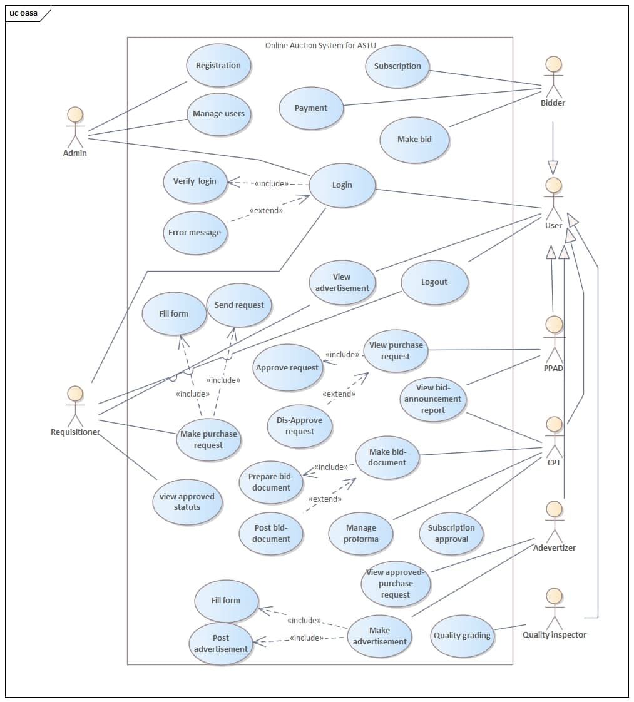

**Iv. Use case description**

Table 5 Use case description for login

|  |  |
| --- | --- |
| Use case name | Login |
| Use case ID | 01 |
| Use case description | Whenever the user tries to access his/her personal page like advertising, posting, etc. he/she is required to provide his/her username and password and the user will log in. |
| Actor | All user |
| Pre-condition | The user must have a valid username and password |
| Post-condition | Leaving from the login page and will join the home page |
| Main flow | * The user opens the system. * The user fills the login form by writing his/her username and password * The login information is sent to the server for authentication by clicking the login button * The system displays the home page. |
| Exceptional flow | * If he/she enters wrong data the system displays a message to enter correct data |
| Include | Create account |
| Business rule | Valid username and password should be acquired |
| Frequency of use | Once in every single-use |

Table 6 Use case description for Purchase Request

|  |  |
| --- | --- |
| Use case name | Purchase Request |
| Use case ID | 02 |
| Use case description | Provide service seeker (Requisitioner) to ask or send a purchase request to bid committee |
| Actor | Requisitioner |
| Pre-condition | * They have to navigate to the website. * The user has a valid user name and password, which is recognized by the system. |
| Post-condition | The request reaches to bid committee |
| Main flow | * The system displays the homepage. * The user chooses the request form tab. * Requisitioner fills request form. * Submits its request form for approval. * The system displays a Successful message. |
| Exceptional flow | * If the user fills the form incorrectly, the system will generate an error message. |
| Include | - |
| Business rule | A valid department or sector should have a valid user and a request should be submitted by that user |
| Frequency of use | Whenever service is requested |

Table 7 Use case description for Register

|  |  |
| --- | --- |
| Use case name | Register |
| Use case ID | 03 |
| Use case description | The bidder must register into the system to participate in the bidding process |
| Actor | Admin |
| Pre-condition | The user must have a valid email address. |
| Post-condition | Having a valid username and password |
| Main flow | The user fills in the information that is required in the registration form, information like:   * First name * Last name * Gender * Name of firm/company * Email * Telephone number * Access level * User’s type   Click Submit |
| Exceptional flow | * If the bidder does not enter the correct information into the form, the system notifies them to enter the correct data |
| Include | - |
| Business rule | The information above should be submitted |
| Frequency of use | Ones to register |

Table 8 Use case description for Approve purchase request

|  |  |
| --- | --- |
| Use case name | Approve purchase request |
| Use case ID | 04 |
| Use case description | PPAD observes those service/item lists that have been requested and approve by choosing. |
| Actor | PPAD |
| Pre-condition | Service requests should be sent |
| Post-condition | Approve/Dis-approve for advertisement |
| Main flow | * The system displays the homepage. * View purchase request * The director chooses the requested services tab. * The director approves the requested service. |
| Exceptional flow | - |
| Include | - |
| Business rule | Service seekers first should make a request |
| Frequency of use | Once |

Table 9 Use case description for Dis-approve purchase request

|  |  |
| --- | --- |
| Use case name | Dis-approve purchase request |
| Use case ID | 05 |
| Use case description | PPAD observes those service/item lists that have been requested and approve by choosing. |
| Actor | PPAD |
| Pre-condition | Service requests should be sent |
| Post-condition | Approve/Dis-approve for advertisement |
| Main flow | * The system displays the homepage. * View purchase request * The director chooses the requested services tab. * The director disapproves of the requested service. |
| Exceptional flow | - |
| Include | - |
| Business rule | Service seekers first should make a request |
| Frequency of use | Once |

Table 10 Use case description for Subscription

|  |  |
| --- | --- |
| Use case name | Subscription |
| Use case ID | 06 |
| Use case description | The bidders should have to subscribe to get access for making a bid for already available bid announcements. |
| Actor | Bidder |
| Pre-condition | * They have to navigate to the website. |
| Post-condition | Bidders get access to participate in any bidding. |
| Main flow | **The flow of event:**   * The system displays the homepage. * Bidders enters a new subscription tab. * Attach all the necessary document for the subscription. * Click send button. |
| Exceptional flow | * If the user fills the form incorrectly, the system will generate an error message. |
| Include | Refresh, the file permanently saved to the database |
| Business rule | Bidders should submit all valid documents for the bid. |
| Frequency of use | Once in valid time |

Table 11 Use case description for Quality grading

|  |  |
| --- | --- |
| Use case name | Quality grading |
| Use case ID | 07 |
| Use case description | The quality inspector should check the products which are proposed by the bidders, after that he/she gives a ranking for the specific products which helps for automatic bid computation |
| Actor | Quality inspector |
| Pre-condition | * They have to navigate to the website. * The user has a valid user name and password, which is recognized by the system. * Submitted bid document. |
| Post-condition | Bidders get their rank based on their quality |
| Main flow | * The system displays a document that has the technical feature of the bid form. * User gives valuation to the inspection. * The user submits the rank. |
| Exceptional flow | None |
| Include | Refresh, the file permanently saved to the database |
| Business rule | Central procurement should permit to make the quality assessment |
| Frequency of use | Once in valid time |

Table 12 Use case description for Make crud operation

|  |  |
| --- | --- |
| Use case name | Make crud operation |
| Use case ID | 08 |
| Use case description | If any redo operations necessary for already submitted forms and advertisements, any users can use these crud operations to make the redo. |
| Actor | Advertiser, Bidder, CPT, Requisitioner, PPAD |
| Pre-condition | The forms will update |
| Post-condition | The content of the form will be update |
| Main flow | * The system displays the homepage. * The bidder chooses already prepared forms * Make any crud operation * The bidder submits. |
| Exceptional flow | None |
| Include | Refresh, the file permanently saved to the database |
| Business rule |  |
| Frequency of use | Every time before posting the document |

Table 13 Use case description for Payment

|  |  |
| --- | --- |
| Use case name | Payment |
| Use case ID | 09 |
| Use case description | Bidders after paying the initial payment for the bid they announce the purchaser to get an identification number from him/her for |
| Actor | Bidder |
| Pre-condition | * They have to navigate to the website. |
| Post-condition | Bidders get identification number which helps for making a bid |
| Main flow | * The system displays the homepage. * The bidder chooses the bid-form tab. * Payment page will display * Bidders insert necessary information to complete the payment * Click send button. |
| Exceptional flow | None |
| Include | Refresh, the file permanently saved to the database |
| Business rule | Bidders should submit all valid documents for the bid and they should have a subscription. |
| Frequency of use | Once in valid time |

Table 14 Use case description for Grant bid access

|  |  |
| --- | --- |
| Use case name | Grant bid access |
| Use case ID | 10 |
| Use case description | Bidders get one time username and password for the bidding process after the system check the payment that bidders already commit. |
| Actor | system |
| Pre-condition | * The payment process should complete. |
| Post-condition | Bidders get a one-time access key for a specific bid |
| Main flow | * The system checks the payment. * The system give authorization to the eligible bidders. |
| Exceptional flow | None |
| Include | Refresh, the file permanently saved to the database |
| Business rule | Payment should submit |
| Frequency of use | Once in a year for each bidder |

Table 15 Use case description for logout

|  |  |
| --- | --- |
| Use case name | Logout |
| Use case ID | 11 |
| Use case description | The user will log out of the system when he/she finish. |
| Actor | All user |
| Pre-condition | The user must log in |
| Post-condition | Back to log in page/homepage |
| Main flow | * The user clicks on the logout button * His/her information is removed from the local storage. * The system leads their page to their home page |
| Exceptional flow |  |
| Include | Refresh, the file permanently saved to the database |
| Business rule | - |
| Frequency of use | Once |

Table 16 Use case description for Prepare bid document

|  |  |
| --- | --- |
| Use case name | Prepare bid document |
| Use case ID | 12 |
| Use case description | The central procurement first should prepare the bid document based on the approved request to make the purchasing and auction process start |
| Actor | Central procurement |
| Pre-condition | Requisitioner request should be approved by PPAD |
| Post-condition | Post document |
| Main flow | * The system displays the homepage. * The central procurement group chooses the type of form needed for the approved bid by the director. * Users choose the bid document tab * The user prepares a bid document. |
| Exceptional flow | * If the user fills the form incorrectly, the system will generate an error message. |
| Include | Refresh, the file permanently saved to the database |
| Business rule | The request should approve. |
| Frequency of use | Every time for any document preparation |

Table 17 Use case description for post-bid document

|  |  |
| --- | --- |
| Use case name | Post bid document |
| Use case ID | 13 |
| Use case description | The central procurement after preparing their bid documents they will post them to be available for any bidders |
| Actor | Central procurement |
| Pre-condition | Bid document preparation should complete |
| Post-condition | Available for users |
| Main flow | * The user submits the bid document. * User chose bid form tab * The central procurement group submits the chosen type of form. |
| Exceptional flow | * If the bid document should not fill or prepare in the right manner |
| Include | Refresh, the file permanently saved to the database |
| Business rule | - |
| Frequency of use | Once for any prepared document |

Table 18 Use case description for fill form in make advertisement

|  |  |
| --- | --- |
| Use case name | Form fill |
| Use case ID | 14 |
| Use case description | Advertiser prepares the advertisement forms by filling in all the necessary information. |
| Actor | Advertiser |
| Pre-condition | All purchased request should get permission for advertisement |
| Post-condition | Post advertisement |
| Main flow | * The system displays the homepage. * The advertiser views already approved advert requests. * The advertiser chooses the make advert tab. * Fil the advertisement form |
| Exceptional flow | * If the advertisement form should not fill or prepare in the right manner |
| Include | Refresh, the file permanently saved to the database |
| Business rule | - |
| Frequency of use | Once for any prepared bid documents |

Table 19 Use case description for Post advertisement in make advertisement

|  |  |
| --- | --- |
| Use case name | Post advertisement |
| Use case ID | 15 |
| Use case description | After preparing the advertisement for any approved purchases, which need to be posted on the system to make it available for any users of the system. |
| Actor | Advertiser |
| Pre-condition | Advertisement form should fill |
| Post-condition | Available for users |
| Main flow | * The advertiser posts the advertisements. |
| Exceptional flow | * If the advertisement form should not fill or prepare in the right manner |
| Include | Refresh, the file permanently saved to the database |
| Business rule | - |
| Frequency of use | Once for any prepared advertisement forms |

Table 20 Use case description for view advertisement

|  |  |
| --- | --- |
| Use case name | view advertisement |
| Use case ID | 16 |
| Use case description | Any user of the system can see an advertisement. |
| Actor | All users |
| Pre-condition | Posting the advertisement should complete |
| Post-condition | Available for users |
| Main flow | * Open the websites * Enter username and password * systems inter to the home page * Chose view advertisement tab |
| Exceptional flow | * If the advertisement form should not fill or prepare in the right manner |
| Include | Refresh, the file permanently saved to the database |
| Business rule | The advertisement should available |
| Frequency of use | Once for any prepared advertisement forms |

Table 21 Use case description for View bid announcement

|  |  |
| --- | --- |
| Use case name | View bid announcement |
| Use case ID | 17 |
| Use case description | Once the system performs the bid computation and the predefined data and time meet the bid result should be accessible for central procurement and PPAD |
| Actor | Central procurement, PPAD |
| Pre-condition | Bid computation should perform |
| Post-condition | Result report generate |
| Main flow | * Open the websites * Enter username and password * Enter into the home page * Chose view bid result tab |
| Exceptional flow | **-** |
| Include | Refresh, the file permanently saved to the database |
| Business rule | Based on price and quality assessment bid computation should first perform by the system. |
| Frequency of use | Whenever needed |

Table 22 Use case description for Make bid

|  |  |
| --- | --- |
| Use case name | Make bid |
| Use case ID | 18 |
| Use case description | If users see the advertisement for the bid, if they have already a subscription, and if they make a payment announcement they can directly participate in a bid. |
| Actor | Bidders |
| Pre-condition | Bidders should have subscription and payment announcement should be complete |
| Post-condition | A successful message will display and they can view a bid, which they participate in already. |
| Main flow | * Open the websites * Enter username and password * Enter into the home page * Chose to make a bid * Fill the form * Submit the form |
| Exceptional flow | * If the bidder does not enter the correct information into the form, the system notifies them to enter the correct data |
| Include | Refresh, the file permanently saved to the database |
| Business rule | Users should have a subscription to be a participant |
| Frequency of use | Once for a specific bid. |

# 3.5 Object Model

## 3.5.1 Data Dictionary

The data dictionary is used to define each class in the system and the member of the class like attribute, operation, and description about the class.

Table 23 Data Dictionary

|  |  |  |  |
| --- | --- | --- | --- |
| **Class** | **Attribute** | **Operation** | **Description** |
| User | First_name  Last_name  Phone_number  User_type  Email  Address | Login ()  Change password ()  Logout ()  View advertisement () | A user is an actor which represents all users of the system and it is the parent class for all other class |
| Central procurement team | CPT_password  CPT_Username | View bid_report ()  Preparebid_document ()  Post bid_document ()  ViewApproved_purchase_request ()  viewBid_announcment () | A central procurement is a group that is responsible to prepare any bid document and make a bid. |
| Bidder | Password  User_Name | Make bid () | Any subscriber that can make a bid. |
| Subscriber | Subscriber_Address  Subscriber_document  Subscriber_Email  Subscriber_id  Subscriber_Name  Subscriber_phone | Subscription ()  Payment () | Any legal organization that can participate in the bid process |
| Requisitioner | Directorate_disc  Directorate_Name  Dirc_Username  Dirc_Password | fillForm ()  makePurchase_request ()  send Request ()  viewApproved_request () | Any directorates of ASTU. |
| Advertiser | Adve_password  Adve_Username | ViewApproved_purchase_request ()  Prepare Advertisement ()  Post Advertisement () | A person is responsible for preparing an advertisement for an already approved bid document and post the advertisement on the advertisement page. |
| Admin | Admin_id  Admin_password | Manage user ()  Registration () | The system controller and manage all users. |
| PPAD | Directorate_disc  PPAD_Password  PPAD_Username | ViewPurchase_request ()  ApprovePurchase_request ()  DisapprovePurchase_request ()  ViewBid_announcment () | Directorate, which is responsible for all purchase and bid processes. |
| Quality inspector | QUI_Password  QUI_ Username | Quality Grading () | A group that checks the quality of the proposed product by the bidders and give a quality valuation to the specific product |
| Advertisement | Advert_date ()  Advert_discription ()  Advert_type | View ()  CrudOperation () | A class that holds any of already approved advert |
| Bid report | Bid_id  Open_Date  Winning_Price  Winners_Name | View () | After bid computation, the system displays a bid report. Therefore, the bid repost contains and displays already computed bid values. |
| Bid | Bid_date  Bid_id  Bid_type  Bid_discription  Bid_ammount  Reserved_price  Sealing_price  Starting_price | CrudOperation ()  View () | A class that holds any of the already submitted bids |
| Approved purchase request | Request_discription  Directorate_Name  Date | View () | A class that holds any of already approved purchase request |
| ProformaManagnment | Date  Pro id  Proforma_Document  Reported Document | View () | Stores all the responses for available proforma and also reported documents |
| Purchase Request | Date  Dirc_Name  Purchase_discription  Type | View () | All request which is made by different directorates |
| FileManagnment | Bid_document  Bid_id  Reported_document | View () | Stores all files which are related to bid. |

## 3.5.2 Class Diagram

Figure 2 Class diagram

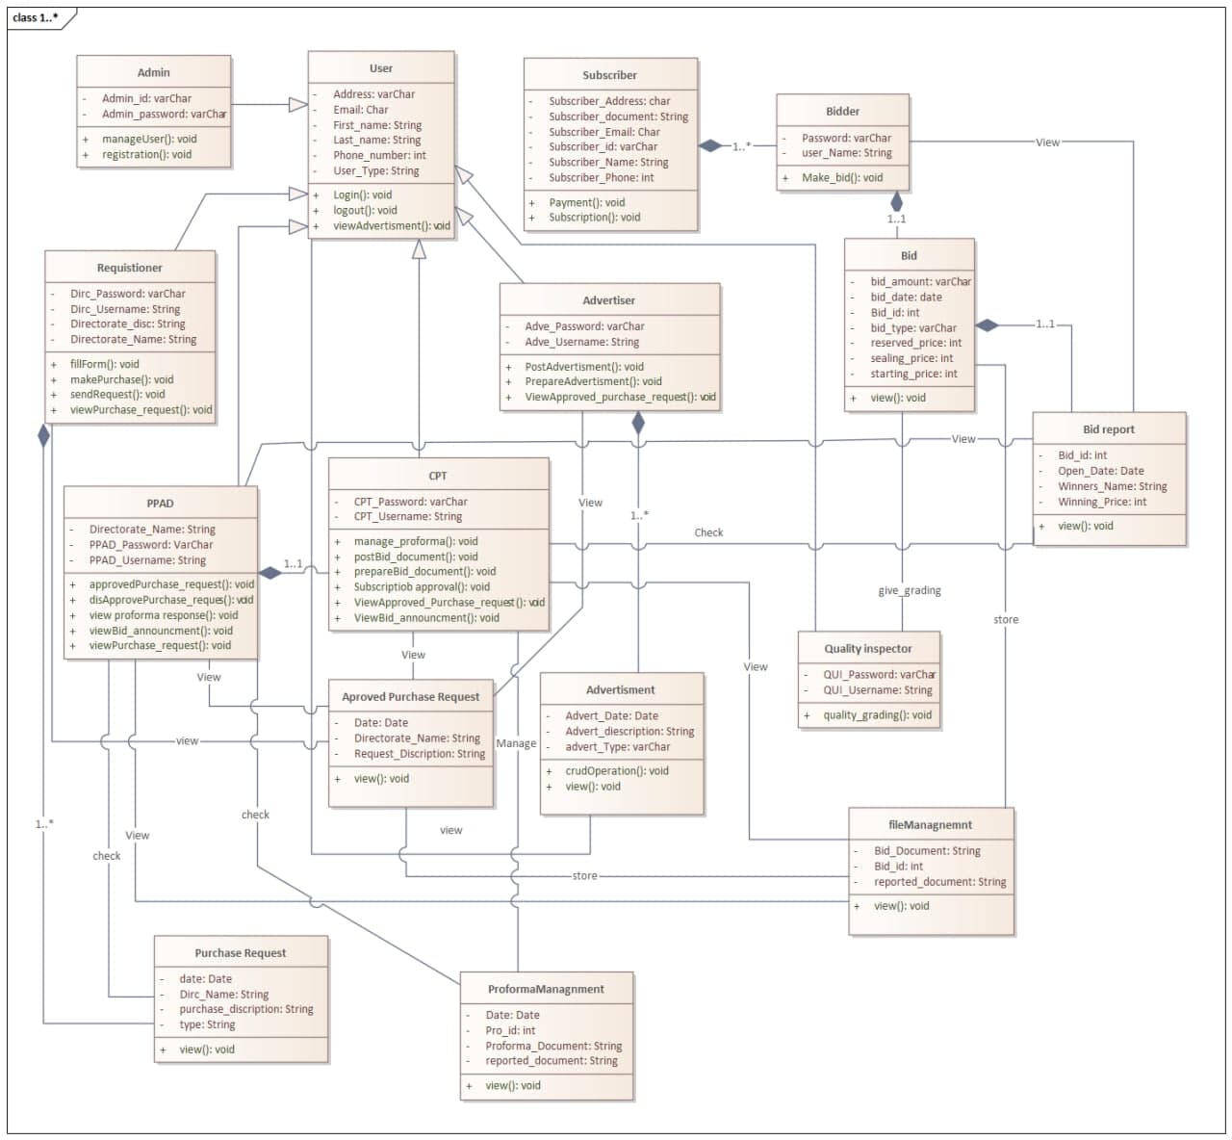

# 3.6 Dynamic Model

## 3.6.1 Sequence Diagram

**A. Requisition**

Is the process in which Requisitioner passes its request to the responsible division to gain permission and collect its good or service.in this request-response process the Requisitioner passes through a sequence of processes, these processes are illustrated in a diagram below.

Figure 3 Requisition sequence diagram

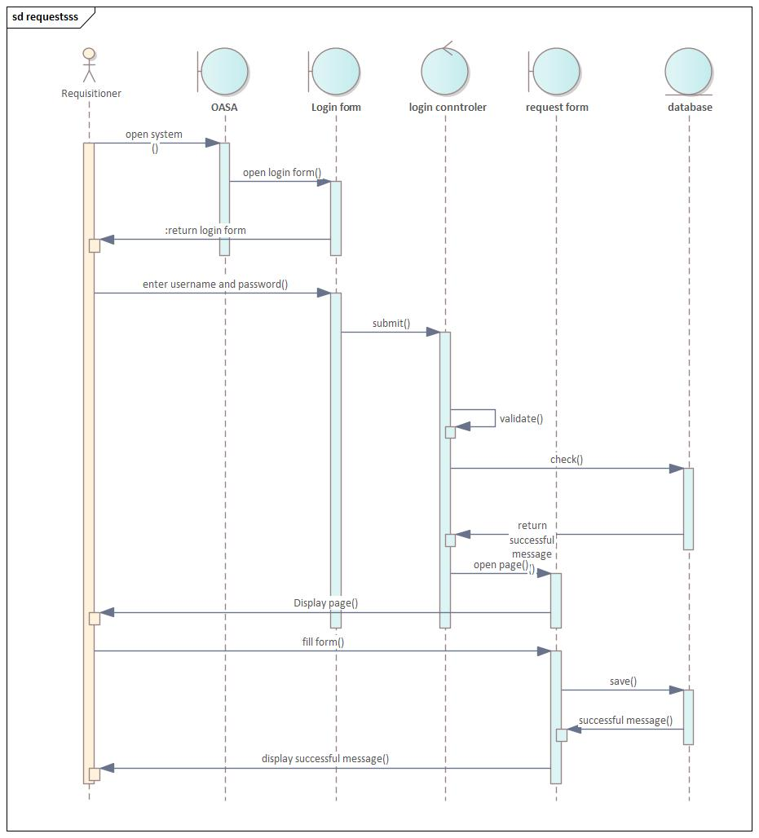

**B. Advertisement**

The advertisement processes take place by the advertiser and those requests will go through a series of operation and gets to the advertiser. This is where the advertiser logs into its side of the system and publishes it goes through the following activity.

Figure 4 Advertisement sequence diagram

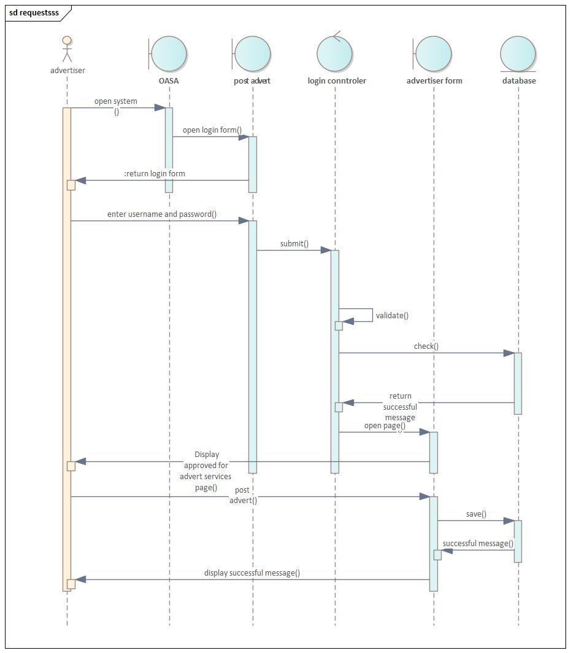

**C. Make bid document**

The bid document preparation includes choosing types of bid form and publication of this type and full submission of the document to the next part of the system process. The sequence takes place in the following manner.

Figure 5 Make bid document sequence diagram

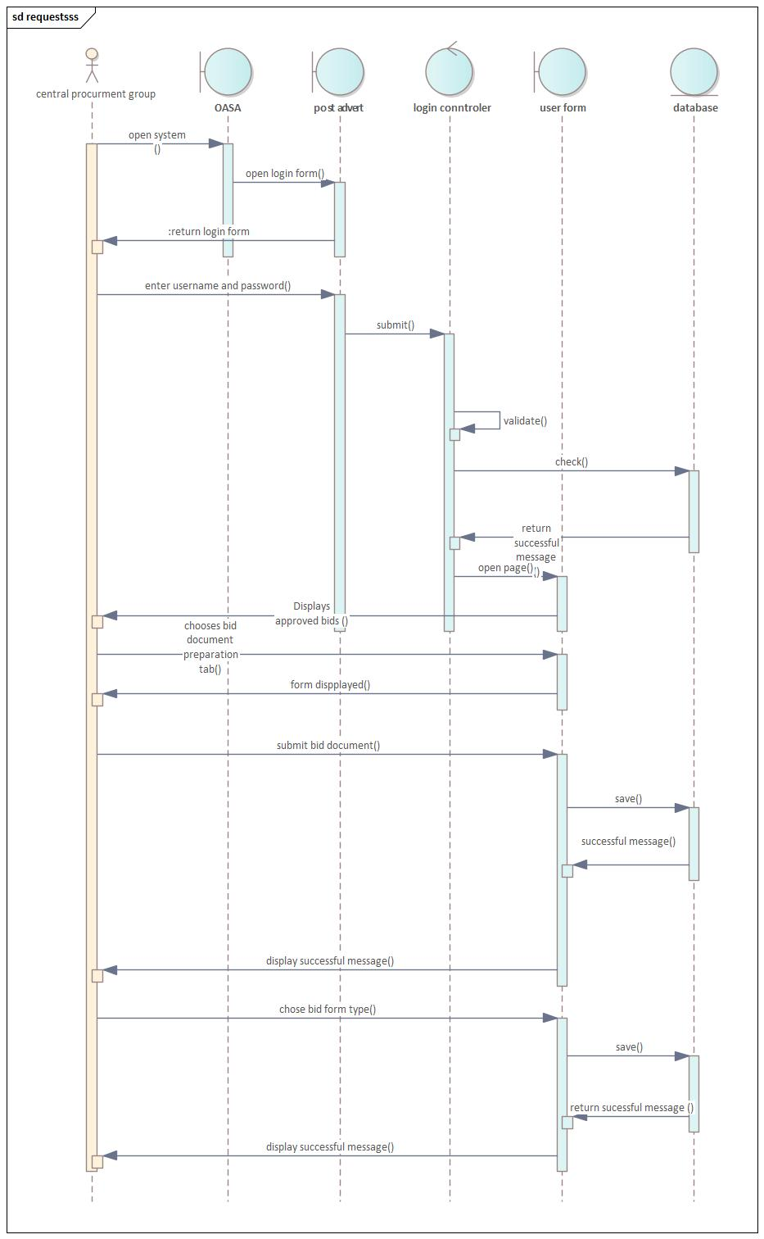

**D. Post bid document**

The central procurment after preparing the bid document they post the bid document through this kind of sequence process

Figure 6 Post bid document

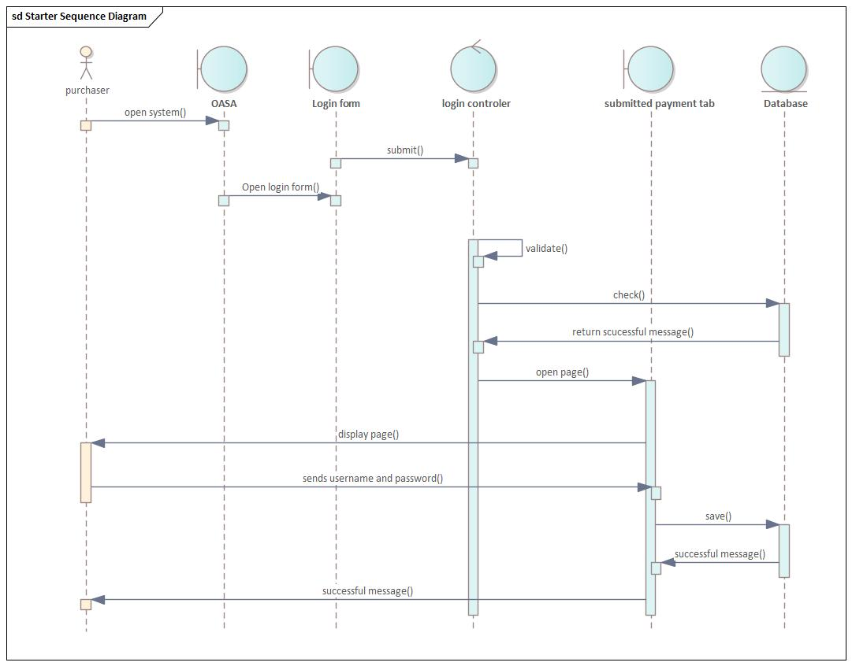

## 3.6.2 Activity Diagram

**1. login**

Login activity takes place for all authorized users to enter their side of the system. The activity to logo into the system takes place as below.

Figure 7 Login activity diagram

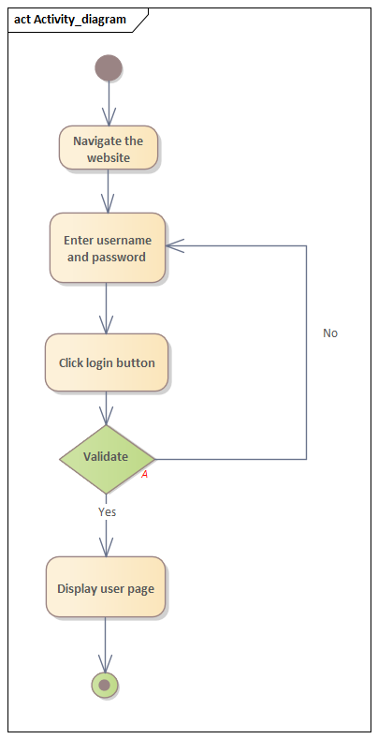

**2.Purchase request**

The activity to make a purchase request by the requisitioner is illustrated in the below diagram.

Figure 8 Purchase request activity diagram

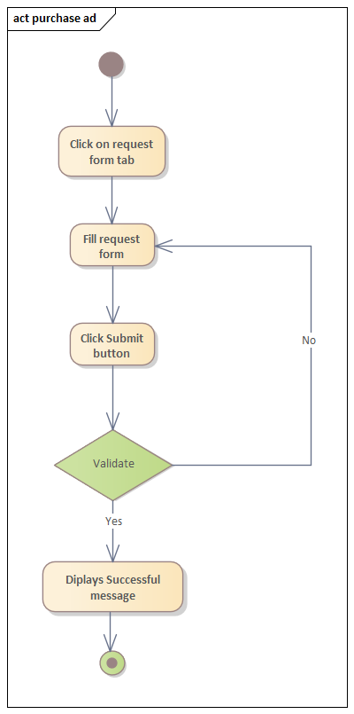

**3.Registration (To register bidders in our system)**

To register bidder(subscription) in our system the bidder's legality is validated and only if they are eligible new subscription takes place and activity are as shown below.

Figure 9 Registration activity diagram

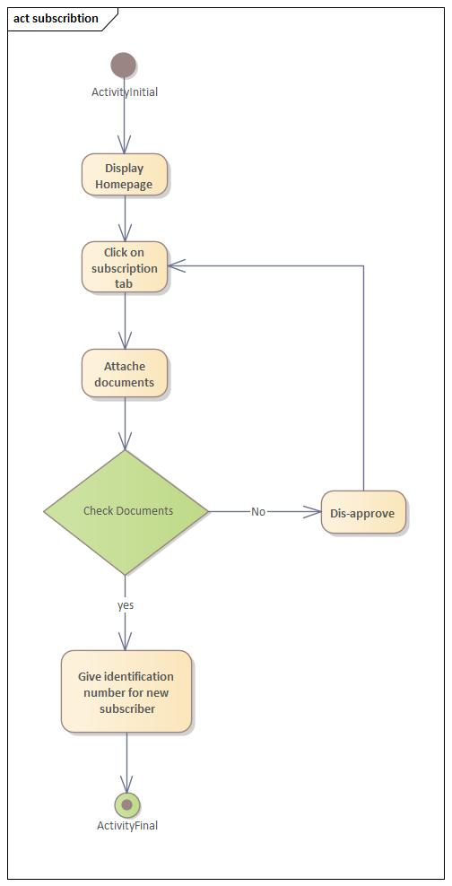

**4. Make advertisement (Fill advertisement form and post it)**

The advertisement process takes place by the advertisers and those requests will go through a series of operation and gets to the advertiser. This is where the advertisement logs into its side of the system and publishes the advertisement; the advertisement to publish its advertisement goes the following activities.

Figure 10 Make advertisement activity diagram

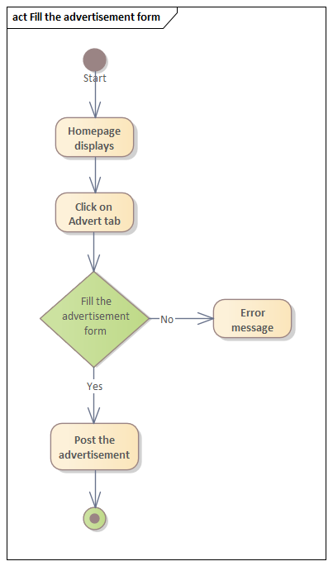

## 3.6.3 State Chart Diagram

1. **Requisition**

The flow for Requisitioner requests for purchase is as follows.

Figure 11 Requisition state chart diagram

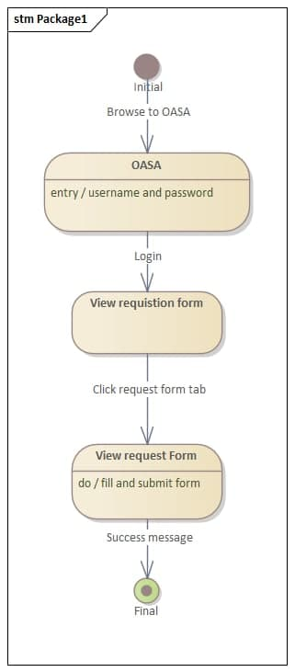

1. **Advertisement**

The flow of events carries out in advertisements starting from browsing the system to posting or publishing the advert is put in this diagram.

Figure 12 Advertisement state chart diagram

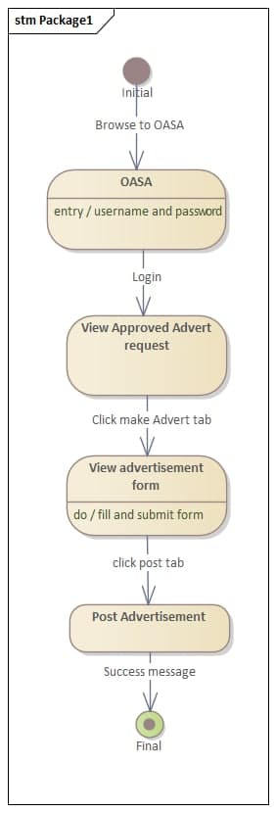

1. **Subscription**

Is made to validate the eligibility of new incoming bidders for a bid and given the special eligibility identifier for the bidder. The following diagram illustrates the flow of this subscription process.

Figure 13 Subscription state chart diagram

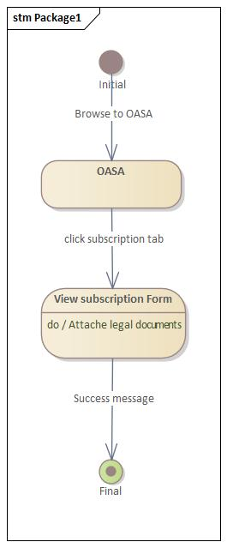

# Chapter 4

# 4. System design

# 4.1 Overview of system design

The basic of the system design is to plan a solution for the problem. This phase is composed of several systems. This phase focuses on the detailed implementation of the feasible system. Its emphasis on translating design specifications to performance specifications. System design has two phases of development logical and physical design.

During the logical design phase developers describes inputs (sources), outputs (destinations), databases (data stores), and procedures (data flows) all in a format that meets the user requirements. The developers also specify the user needs and at a level, that virtually determines the information flow in and out of the system and the data resources. Here the logical design is done through data flow diagrams and database design.

The logical design is followed by physical design or coding. The physical design produces the working system by defining the design specifications, which tell the programmers exactly what the candidate system must do. The programmers write the necessary programs that accept input from the user, perform necessary processing on accepted data through call and produce the required report on a hard copy or display it on the screen.

## 4.1.1 Purpose of the system design

The software design section describes the architecture and model of the system with high quality by providing value-added services to the bidder and ASTU purchasing and property directorate. Implementing a high-quality system depend on the nature of the design created by the designer. It provides a complete architectural overview of the proposed system. It is intended to express the significant architectural decisions that have been made on the system. The system should be equipped with some sort of structure and organization throughout the system. Such that the CRUD rules, as well as MVC (Model View Controller) layout, should be maintained. The basic goal of system design is to plan a solution for the problem.

## 4.1.2 Design goal

The Design Goals specify the qualities of the system that should be achieved and address during the design of the system. Therefore, there is a lot of design goal to be achieved, yet the following are some of the design goals that are attempted to be maintained for this particular system; namely Online auction system for ASTU.

**Performance:**

* **Response time**: The amount of time it takes from an initial user request to receipt of a response. Should be fast given today’s user demand.
* **Storage**: To work efficiently the processor has to be more than 2GB RAM and HD (hard disk) storage to be more than 100MB

**Dependability:**

* **Robustness**: The multi-platform environment of the web places extraordinary demands on the program because the program must execute reliably in a variety of systems. The ability to create a robust program was given high priority in the design of PHP. It checks your code at a compiled time and runs time.
* **Scalability**: More bidders online stand for the increased number of users all making requests. The application must be scalable, that is it has to be able to process those increasing numbers of requests just as rapidly as before. This means proactively adding more hardware so that correct scaling and architecture are in place and ready to handle the increasing load.
* **Security**: ASTU online bidding system should be secured, i.e., by updating system as and for, by using digital signature, encrypted security system and by not allowing other users or unauthorized users to access data that has no the right to access it.
* **Reliability**: the information provided by the system is as reliable as it is present on the web page interface, and this is maintained by the persistent database.

**Maintenance:** Focused on upgrading an application to ensure it remains productive and cost-effective.

* **Availability**: The ability for the application to be usable by its intended users during advertised hours. Any faller that affects a critical component severely enough by decreasing the number of a single point of failure in an environment as long as there is an internet connection and system failure of the system can disrupt availability.
* **Recoverability**: the ability to recover an application environment in the event of system failure or data loss. If a critical component fails and is not recoverable, availability will become non-existent improving maintainability. A related concept reduces the event of failure and therefore can improve availability in the event of failure.

**End-User Criteria:** The system should have a simple and understandable graphical user interface such as forms and buttons, which have descriptive names. It should give a reliable response for each user comment. All the interfaces, forms, and buttons are written or designed in a simple language or common language so that the user can access it without any difficulty. Moreover, has to be interactive, user friendly.

# 4.2 Proposed system architecture

The following diagrams can furthermore represent the system architecture. It shows the entire interaction among the users (Bidder, Central-Procurement team, Advertiser, Quality-Inspector, PPAD, and Administrators) and the web system between the storage and databases.

**Client to server communication**

The client uses the OAS-ASTU websites to get services from the system. The system user-side is designed using an interactive interface and java-script frameworks and bootstrap are used to design it. The back-end of the system is designed using a relational database MYSQL and a real-time database that is a Google firebase base database. Native-PHP is used for connectivity of the user-side of the system to the back-end. Furthermore, firewall, Apache servers are used on the server.

**Online Auction System for ASTU: OAS-ASTU**

Website that can be access with any internet capable device: computer, smartphone

It has pages with different functionality at the front-end.

**Client**

**(User Side)**

HTTP request HTTP response **Internet connection**

Online Auction System for ASTU at the public domain run on the server. Firewall, Apache server are used.

**Server**

**Side**

Request Response

**Database: MYSQL/ Firebase database**

This **relational-database** consists the entire data that are generate and perform on the system.

Google firebase database are used for cloud storage

**Database**

**(Storage)**

## 4.2.1 System process

The following diagrams show the relationship of components.

* The following diagram represents a system process of how a front-end user Property and purchase and property administer directorate can access the system and get services.

Figure 14 View purchase request system process diagram

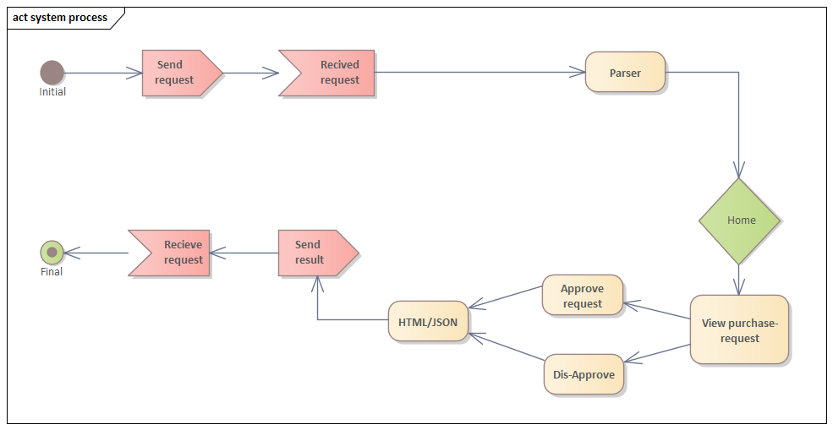

* The following diagram represents a system process of how a front-end user Bidders can subscribe to the system and get services.

Figure 15 Subscription system process diagram

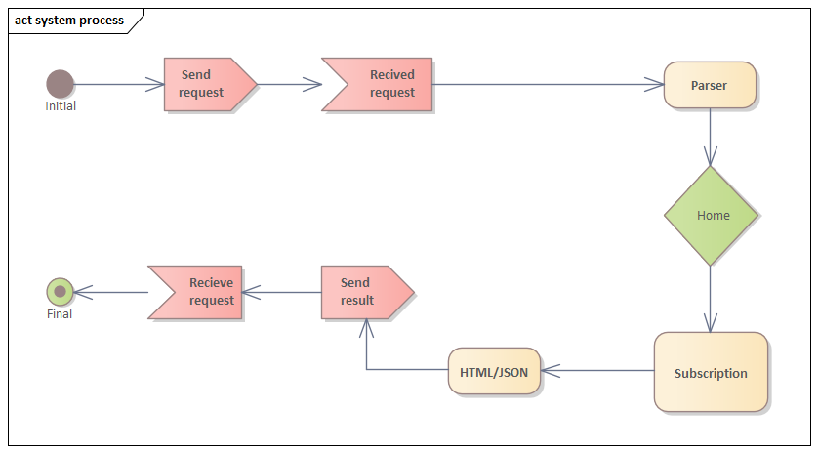

* Overall system process of the system.

Figure 16 Complete system process diagram

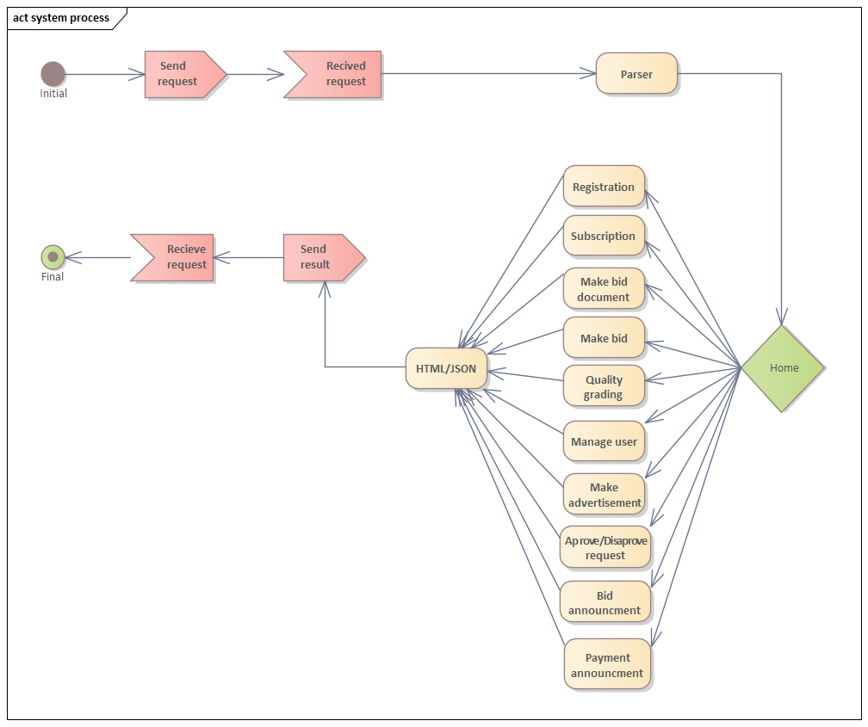

## 4.2.2 Subsystem decomposition

Subsystems are a collection of classes, associations, operations, events, and constraints that are closely interrelated with each other. The objects and classes from the object model are the “seeds” for the subsystems. In UML, subsystems are modeled as packages.

Figure 17 Subsystem decomposition diagram

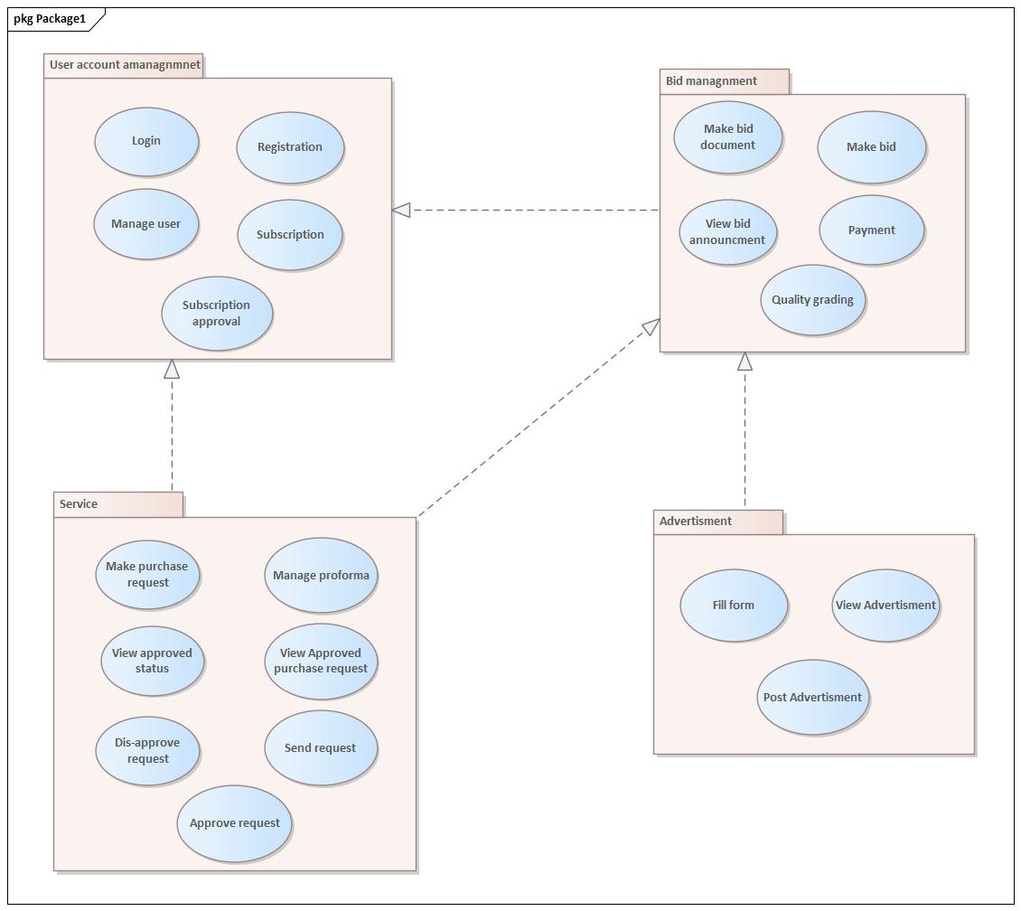

## 4.2.3 Hardware/ software mapping

In this system design, mainly three hardware components are there the client-side, server-side, and database side. When implementing the system, necessary software is loaded to each side, hardware components and network should be installed between each side. Then each sub-system software will be assigned and configured to the mapped hardware. After that, the local area network will be connected to the internet and the system become functional.

Figure 18 Hardware/software mapping diagram

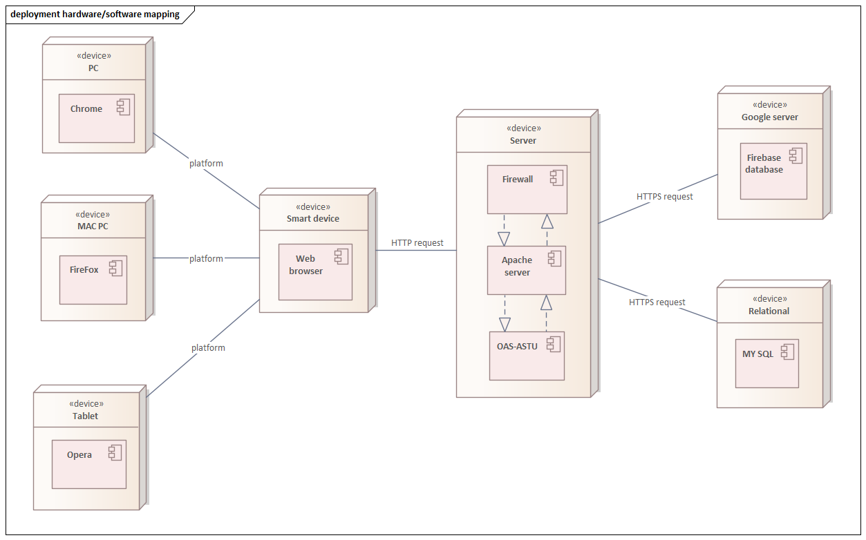

## 4.2.4 Persistent data management

This section provides a mapping of the class diagram’s classes and objects that were identified in the requirement analysis phase into a relational database format.

Figure 19 Persistent data management diagram

Relational database tables

Class diagram classes and objects

User mapping

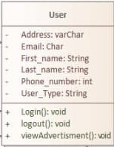 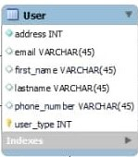

Requestioner

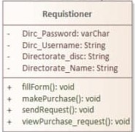 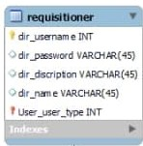

Purchase Request

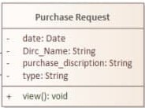 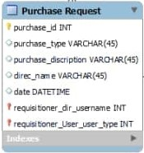

Bid Report

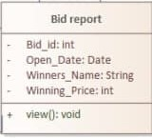 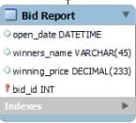

Subscriber

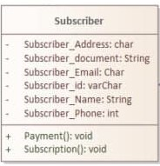 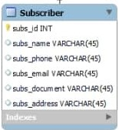

Approve purchase request

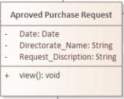 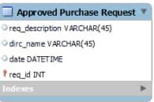

Advertisement

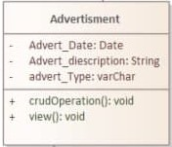 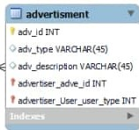

Advertiser

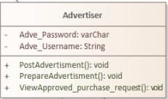 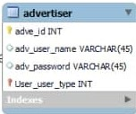

Admin

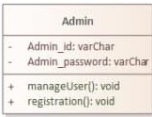 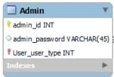

Bid

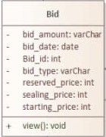 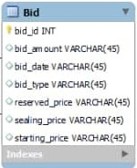

FileManagnment

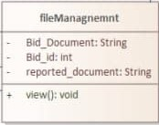 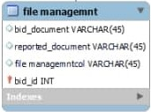

Quality inspector

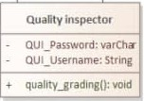 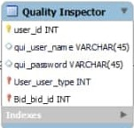

Bidder

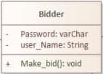 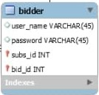

PPAD

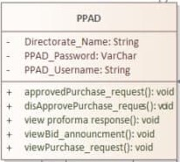 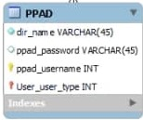

Proforma management

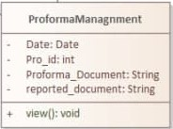 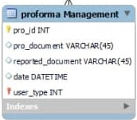

## 4.2.5 Component diagram

The following component diagram represents a group graph of components connected by dependency relationships.

Figure 20 Component diagram

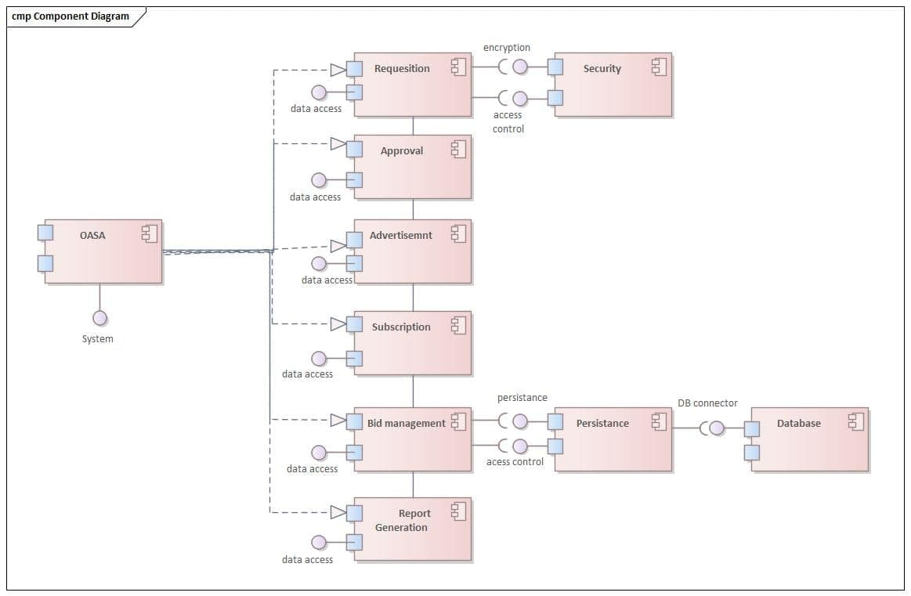

## 4.2.6 Database design

Figure 21 Database design diagram

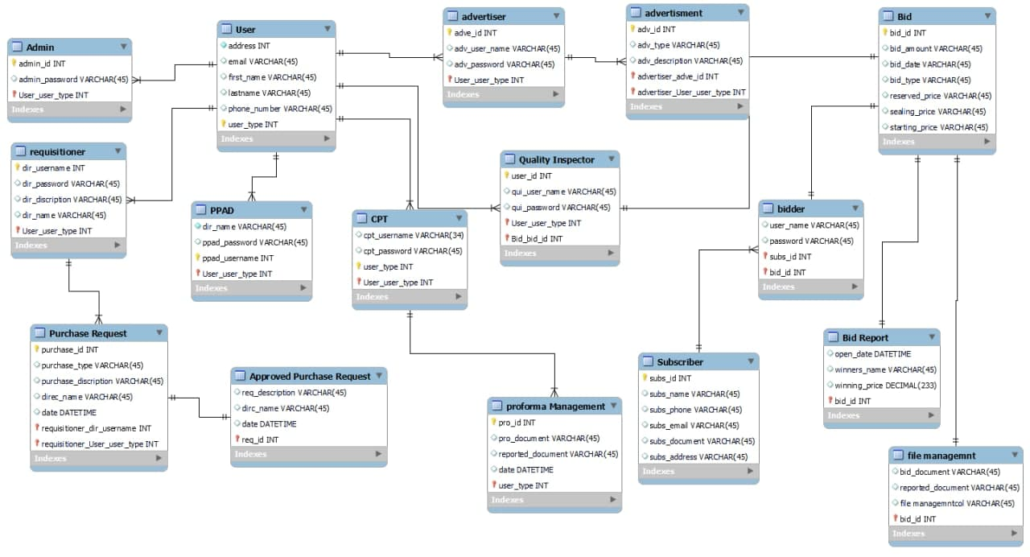

## 4.2.7 Access control

Due to the prototype demonstration nature of the Online Auction System for the ASTU project, the access control issue will address through designing the project based on the available requirement. The different users of the proposed system have different access and privileges to get service from the system.

**Admin: -** list of access and privileges that the admin has

* Registration
* Manage user
* View advertisement
* Login
* Logout
* Perform crude operation

**Requisitioner: -** The Requisitioner have the privilege to

* make purchase request
* perform crude operation
* login
* logout
* view advertisement
* view approved status

**Bidder: -** The bidder has the privilege for

* View advertisement
* Login
* Logout
* Perform crude operation
* Subscription
* Payment
* Fill form
* Make bid

**Advertiser: -** have access to the following operations

* View advertisement
* Login
* Logout
* Perform crude operation
* Make and Post advertisement
* Fill form
* View approved purchase request

**Quality inspector: -** The following operation are given access to the quality inspector

* View advertisement
* Login
* Logout
* Perform crude operation
* Quality grading

**Central procurement team (CPT): -** have the following privileges

* View advertisement
* Login
* Logout
* Subscription approval
* Manage proforma
* Perform crude operation
* Post bid document
* Make bid document
* View bid announcement report

**Purchase and property administrator directorate (PPAD): -** The following are access for the operations given to the PPAD

* View advertisement
* Login
* Logout
* Perform crude operation
* View purchase request
* View bid announcement report
* Approve purchase request
* Dis-approve purchase request

## 4.2.8 User interface design

The following interfaces are list to show some of the interfaces that are going to be implemented in the proposed system.

1. **Login interface**

When user like bidder, purchaser, advertiser and central procurement needs to login into the system the use the interface below.

Figure 22 User interface Login

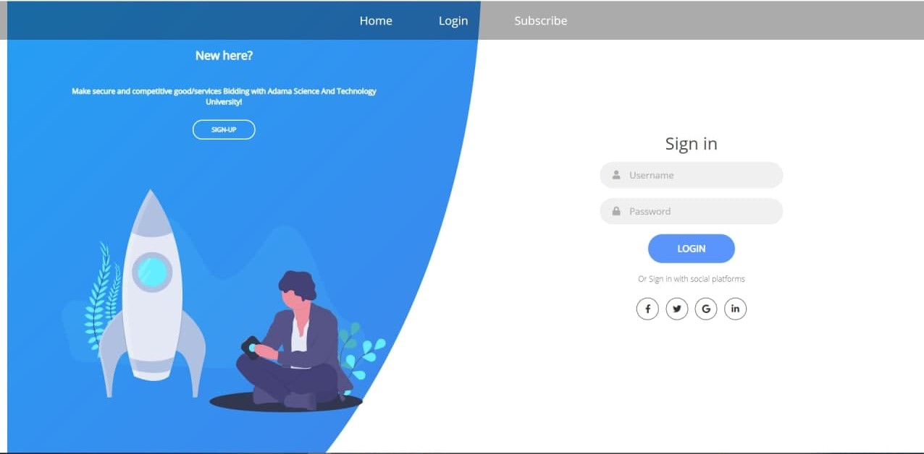

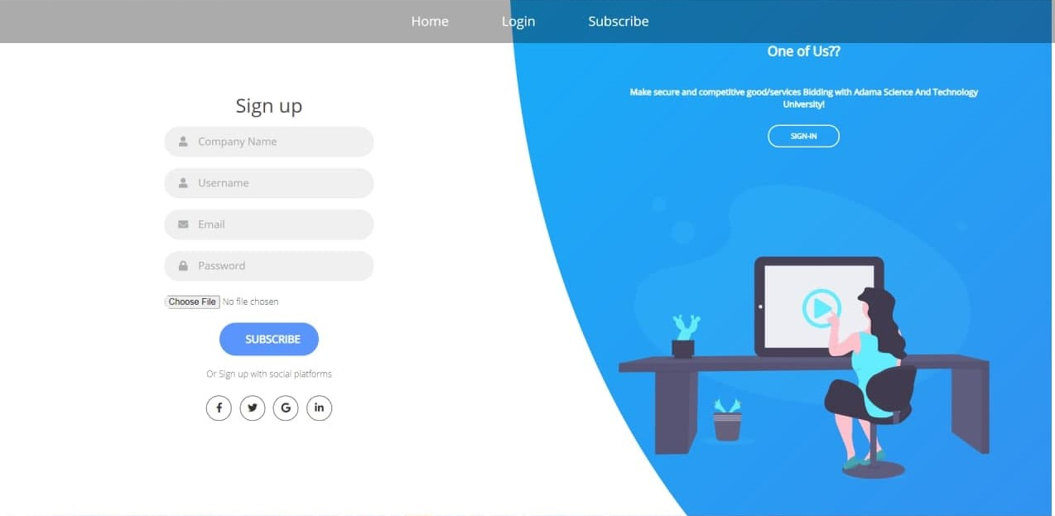

1. **Advertisement interface**

This interface is used to advertise the bids that are requested by service seekers (Requisitioner). In addition, approved by central procurement verifiers to get illegible bidders.

Figure 23 User Interface Advertisement

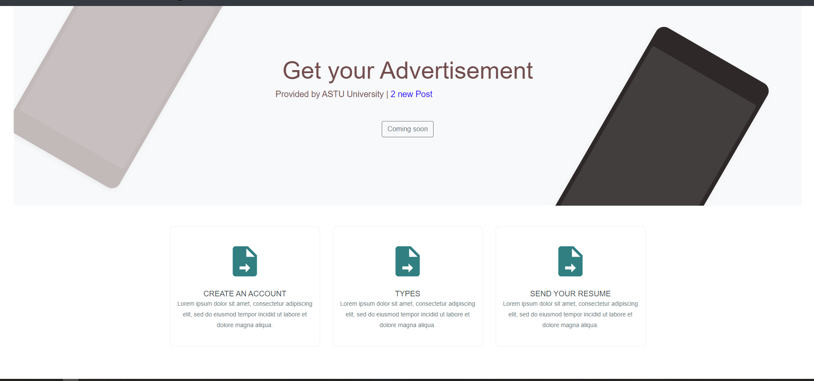

1. **Bidder’s interface**

The bidders to submit their legal documents and to be part of the bid use this interface, the document submitted by this interface will be approved after receiving the expected payment from the bidder.

Figure 24 User interface Bidders

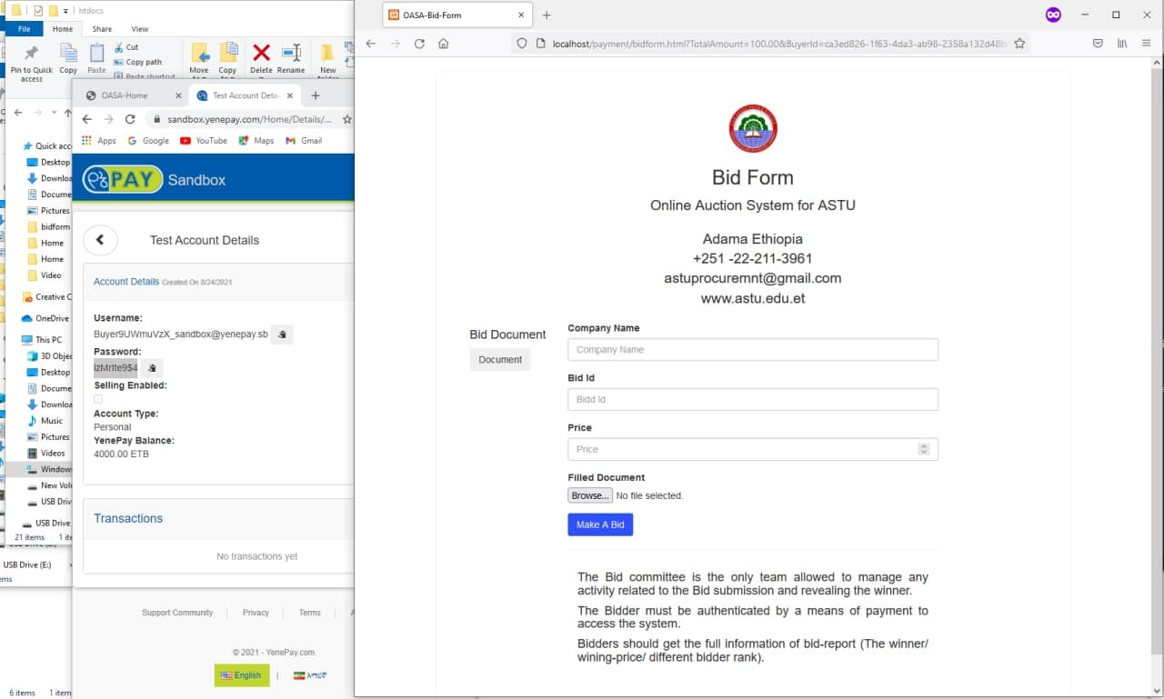

# Chapter 5

# 5. Implementation

# 5.1 Overview

Implementation is the process of integrating the system functions or the development of software and hardware based on the functional and non-functional requirements of the project. Our project implements the functional and non-functional requirements of the proposed system.

# 5.2 Coding Standard

The coding standard on the implementation of the project is the necessary and important thing that provides us different functional advantages.

The purpose of this coding standard is:

* Give a uniform appearance to the code written by different members of our group.
* It improves the readability and maintainability of the code and reduces complicity.
* It helps us to detect errors easily and helps in code reuse.
* It increases the efficiency of the programmer.

Since common code, standards, and guidelines are necessary for the development of the project phase, as a group, we have discussed and came up with the regulation and guidelines on how we code the program.

* **Limited use of global variables**: As much as possible we use a limited number of Global variables. It is because Global variables can be read or modified by any part of the program, making it difficult to remember or reason about every possible use.
* **Error return values and exception handling conventions:** All functions that encounter an error condition should return either a zero or one for simplifying the debugging.
* **Code should be well documented:** The code itself should be self-descriptive and comments should apply to describe why the code is used instead of how it works. Moreover, commenting use as a guide to keep the logic straight while writing the code and to section the code as chapters in long code files.

The code should be properly commented on for understanding easily and Comments regarding the statements increase the understandability of the code.

* **Avoid using an identifier for multiple purposes:** Each variable should be given a descriptive and meaningful name indicating the reason behind using it. This is not possible if an identifier is used for multiple purposes and thus it can lead to confusion to the reader. Moreover, it leads to more difficulty during future enhancements.
* **Avoid using a coding style that is too difficult to understand**: Code should be easily understandable. The complex code makes maintenance and debugging difficult and expensive.
* **The length of functions should not be very large:** Lengthy functions are very difficult to understand. That is why functions should be small enough to carry out small work and lengthy functions should be broken into small ones for completing small tasks.
* **Naming conventions for local variables, global variables, constants, and functions:**

Some of the naming conventions are given below:

* Meaningful and understandable variables names should be nouns and help anyone to understand the reason for using them.
* Class names also should use underscores and Capital letter for every word
* It is better to avoid the use of digits in variable names.
* Indentation: Proper indentation is very important to increase the readability of the code. For making the code readable, some of the spacing conventions are given below:
* There must be a space after giving a comma between two function arguments.
* Each nested block should be properly indented and spaced.
* Proper Indentation should be there at the beginning and the end of each block in the program.
* All braces should start from a new line and the code following the end of braces starts from a new line.

# 5.3 Prototype

**Client-side: the** web browser is installed on the employee side as well as on the bidders or user’s side. This web browser is responsible for interaction between the system and the users of both types. The requests from users to be processed at the server-side of the system emanates from the user interface presented on the web browser.

**Server-side:** is the program running on the server to respond to the requests from the users, which are delivered through the client-side web browser

The server-side performs the following tasks

* User authentication
* Process user input
* Bid computation
* Read/write file on the server
* Database query operations

Programs and applications used in the system includes

* Native PHP
* SQL as database
* Apache server

# 5.4 implementation detail

As a web system, the implementation is divided into two so as our implementation detail.

* Client-side
* Server-side

## 5.4.1 Client-side

This part of the system is the user interface that runs on the user machine for communication of the user and the system. Based on the difference of machine the client-side is developed in a way that it works on minimal resource with minimal performance usage environment, this criterion on the user interface is propagated through selective choosing and uploading contents of the user interface.

The system client side is also divided into two major front-end categories

* Stuff front end
* User front end

Stuff front end is the client-side user interface where the employees are allowed in the system to communicate and navigate.

The user front end is the client-side user interface where bidders and guest users perform their desire and establish communication throughout the system.

## 5.4.2 Server-side

This is the side of the system where the user or client machine service requests are collected processed and handled overall. For this server-side, native PHP programming is used throughout the system.

# 5.5 Deployment

Deployment is the mechanism through which applications, modules, updates, and patches are delivered from developers to users. The methods used by developers to build, test and deploy new code will impact how fast a product can respond to changes in customer preferences or requirements and the quality of each change.

**Nginx: -** is the free, open-source, high-performance HTTP server and reverse proxy, as well as an IMAP/POP3 proxy server. Nginx is popular for its high performance and stability. It comprises a rich feature set and is known for simple configuration. One of the best features of Nginx is the low resource consumption. NGINX Plus is a complete application delivery platform that optimizes the availability and uptime of applications, APIs, and services.

Table 24 Deployment diagram

|  |  |
| --- | --- |
| **Component name** | **Implementation detail** |
| Authentication Controller | Implemented using Php code to perform Authentication. It is required when the user wants to log in. It checks the validity of the user |
| User view | It is the view that interacts with users. |
| Registration Controller | Controls the registration of the new user. After the user fills the registration form this controller sends the request to a system admin controller for approval. |
| Load balancer | This is the component of the Nginx web server that checks which server can handle user requests. |

**Some code from the project**

Figure 25 Sample code from project

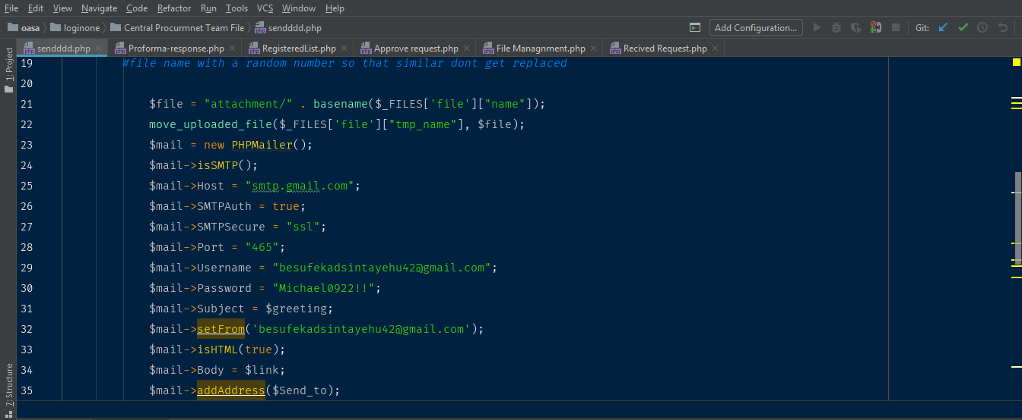

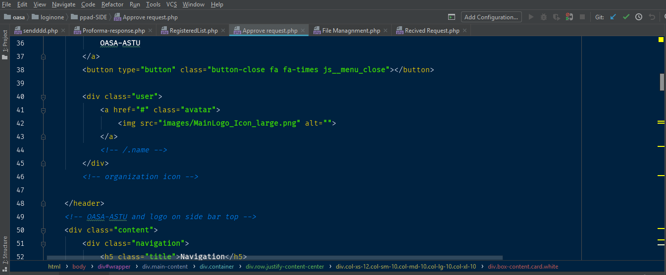

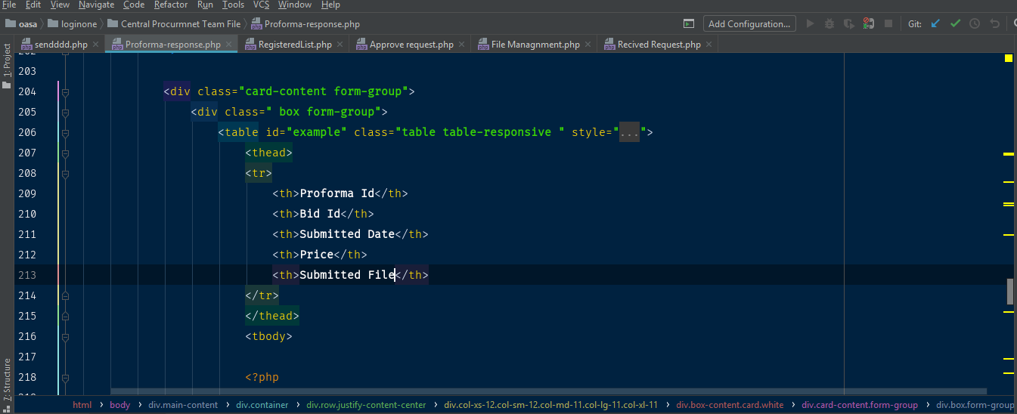

# Chapter 6

# System Testing

# 6.1 Objective

System testing is the inspection of a fully integrated system. The purpose of this checkup is to verify the system’s conformance with both functional and non-functional requirements. Especially the system testing focuses on the back end of the system. Therefore, the following are the objective of testing for our software project:

* To validate that the system is complete and work as expected.
* Verifying the conformance of design, features, and performance with the specifications stated in the product requirements.
* To build confidence in the quality of the system as a whole.
* Preventing as many defects and critical bugs as possible by careful examination.

# 6.2 Scope

This test documentation is done for the following system and version.

Table 25 Testing scope

|  |  |
| --- | --- |
| System Name | OASA (Online Auction System for ASTU) |
| System Description | This is an Online web-based platform that will provide computerized and digitalized ways of doing the current manual works of ASTU purchase and property administer directorate. |
| System Version | 1.0.0 |

The scope includes request-platform, approval and decline mechanism for purchase request, subscription of bidders, make bid, make proforma purchasing, bid report (announcement), E-mail integration, payment mechanism, post bid document, file-management for performed purchase.

# 6.3 Resource

Various resources will be used in the implementation of tests. The main roles are human resources and system resources.

# 6.4 Role

Table 26 Testing role

|  |  |  |
| --- | --- | --- |
| Role | Minimum Resource Recommended | Responsibilities |
| Test Manager | Mikiyas Leul | Provides management oversight Responsibilities:   * Provide technical direction * **Defining** the scope of testing * Management reporting |
| Test Designer | Adenan Mohammmed and Edomiyas Tesfaye | Identifies, prioritizes, and implements test cases  Responsibilities:     * Generate Test Suite * Identifying the appropriate supporting tools * Verify and assess the Test Approach |
| System Tester | Mikiyas Leul | Executes the tests  Responsibilities:   * Execute tests * Recover from errors * Document defects |
| Database Administration/ Database Manager | Besufekad Sintayehu | Ensures test data (database) environment and assets are managed and maintained.  Responsibilities:   * Administer test data (database) |

# 6.5 System

The following table shows the system resources needed to test the proposed system Auction system.

Table 27 Systems of testing

|  |  |
| --- | --- |
| **System Resources** |  |
| Resource | Name / Version |
| Apache server | version 2.4 |
| PHP-Unit | Version 9.5.2 / 2 released February 2021 |
| hash checker | Windows 10 (hash checker) |
| Fake filler | Version 3.3.1 CRX for chrome |
| Computers to conduct testing |  |

# 6.6 Schedule

The testing schedule for the proposed system will be conducted in the following manner.

Table 28 Schedule for system testing

|  |  |  |  |
| --- | --- | --- | --- |
| Milestone Task | Effort (per day) | Start date | End date |
| Test planning | 1 | July 28,2021 | July 31,2021 |
| Test design | 1 | August 1,2021 | August 5,2021 |
| Test development | 2 | August 6,2021 | August 10,2021 |
| Test execution | 2 | August 16,2021 | August 19,2021 |
| Test Evaluation | 3 | August 20,2021 | August 23,2021 |

# 6.7 Test Case Scenarios and Requirement

The listing below identifies those items (use cases, functional requirements, non-functional requirements) that have been identified as targets for testing. This list represents what will be tested.

## Data and Database Integrity Testing

* Verify access to OASA Database.
* Verify correct insertion of data into Database tables.
* Verify payment and database integration.
* Verify correct retrieval of update of database data.
* Verify correct persistence of data.

## Functional Testing

* Verify Various user types registration and login.
* Bidders Login
* Employers Login
* User registration
* Subscription

.

* Payment integration
* Document attachment via email
* Bid algorithm
* Request platform

## User Interface Testing

* Verify ease of navigation through a sample set of screens.
* Verify sample screens conform to GUI standards
* Consistency of page

## Load Testing

* Verify system response when loaded with 20 logged on users.
* Verify system response

## Security and Access Testing

* Verify Log-in from a local PC.
* Verify Log-in from a remote PC.
* Verify Log-in security through user name and password mechanisms.
* Hash checker using window1-10 hash checker

# 6.8 Test strategy

The Test Strategy presents the recommended approach to the testing of the proposed system. The previous section on Test Requirements described what will be tested; this describes how it will be tested. The main considerations for the test strategy are the techniques to be used and the criterion for knowing when the testing is completed. In addition to the considerations provided for each test below, testing should only be executed using known, controlled databases, in secured environments.

## 1. Data and Database Integrity

The databases and the database processes should be tested as separate systems. These systems should be tested without the applications (as the interface to the data). Additional research into the DBMS needs to be performed to identify the tools / techniques that may exist to support the testing identified below.

Table 29 Data and database integrating

|  |  |
| --- | --- |
| Test Objective | Ensure Database access methods function properly and without data corruption. |
| Technique | * Invoke each database access method seeding each with valid and invalid data (or requests for data). * Inspect the database to ensure the data has been populated as intended, all database events occurred properly, or review the returned data to ensure that the correct data was retrieved (for the correct reasons) * Check payment data correctly insert onto the database |
| Completion Criteria | All database access methods function as designed and without any data corruption. |

## 2. Function Testing

Testing of the application should focus on any target requirements that can be traced directly to use cases and business rules. The goals of these tests are to verify proper data acceptance, processing, and retrieval, and the appropriate implementation of the business rules. by interacting with the application via the GUI and analyzing the output (results). Identified below is an outline of the testing recommended for each application:

Table 30 Functional testing

|  |  |
| --- | --- |
| Test Objective | Ensure proper application navigation, data entry, processing, and retrieval. |
| Technique | * Execute each use case, use case flow, or function, using valid and invalid data, to verify the following: * The expected results occur when valid data is used. * The appropriate error / warning messages are displayed when invalid data is used. * Each business rule is properly applied |
| Completion Criteria | * All planned tests have been executed. * All identified defects have been addressed. |

## 3. User Interface Testing

User Interface testing verifies a user’s interaction with the software. The goal of UI Testing is to ensure that the User Interface provides the user with the appropriate access and navigation through the functions of the applications.

Table 31 User interface testing

|  |  |
| --- | --- |
| Test Objective | Navigation through the application properly reflects business functions and requirements including window to window, field to field, and use of access methods (tab keys, mouse movements, accelerator keys).  Window objects and characteristics, such as menus, size, position, state, and focus conform to standards. |
| Technique | * Create / modify tests for each window to verify proper navigation and object states for each application window and objects. |
| Completion Criteria | Each window successfully verified to remain consistent with benchmark version or within acceptable standard |

## 4. Security and Access Testing

Testing focus on:

* md5 hashing function
* System Security, including logging into / remote access to the system. Function security ensures that, based upon the desired security, users are restricted to specific functions or are limited in the data that is available to them.

Table 32 Security and access testing

|  |  |
| --- | --- |
| Test Objective | * Verify that user can access only those functions / data for which their user type is provided permissions. * System Security: Verify that only those users with access to the system are permitted to access them. |
| Technique | * Identify and list each user type and the functions / data each type has permissions for. * Create tests for each user type and verify permission by creating transactions specific to each user type. * Modify user type and re-run tests for same users. In each case verify those additional functions / data are correctly available or denied. |
| Completion Criteria | For each known user type the appropriate function / data are available and all transactions function as expected and run. |

# 6.9 Estimated risk

The major risks that may hinder the testing and verification process are as follows:

* Not meeting deadline schedule.
* Shortage of technical skills to perform required testing.
* Lack of knowledge and experience on testing Software
* **Test organizational and professionalism problems**

# 6.10 Contingency plan

The contingency plan for the risks is:

* Perform load and stress testing with available resource.
* Use the time that we have properly.
* Allocate more time to learn how to test software.
* Conduct testing with minimum and available budget as possible.
* Compile progress and show to stakeholders even if the testing is not fully completed.

# Chapter 7

# User Manual

# Home page

Customers are page visitors who can get a different service that the system will support. You can allow page visitors to find an advertisement without registration or with registration and an OASA user account to login and a subscription mechanism for new bidders that allow them to be participant of any available bids. If a customer has no OASA user account, the system will offer him to create new subscription with new user account. On this page, first the customer opens the website and sees what the website will provide for him.

Figure 26 User manual home page



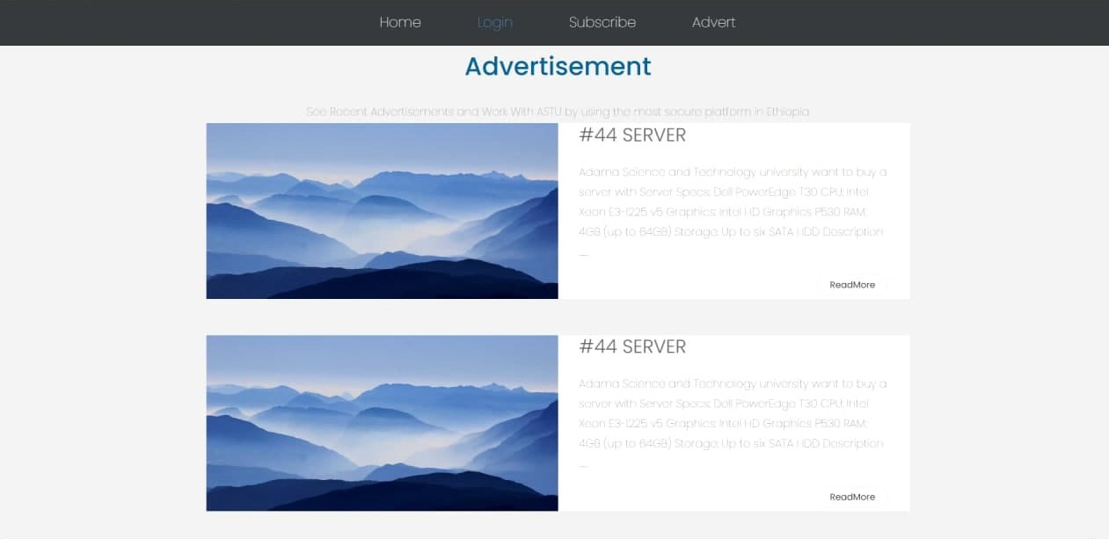

# Login

The system has two login pages the first one for any remote customers that are participant of bids and the second one is for employees of ASTU purchase and property administer directorate and for requester (any ASTU directorates). User can login to the system by entering their username and password.

Figure 27 User manual login



# Subscription

The subscription page is a sign-up mechanism to customers. Once their subscription is approved, they can access the system.

Figure 28 User manual Subscription



The central procurement team make an approval or decline their subscription by checking the validation of their subscription document.

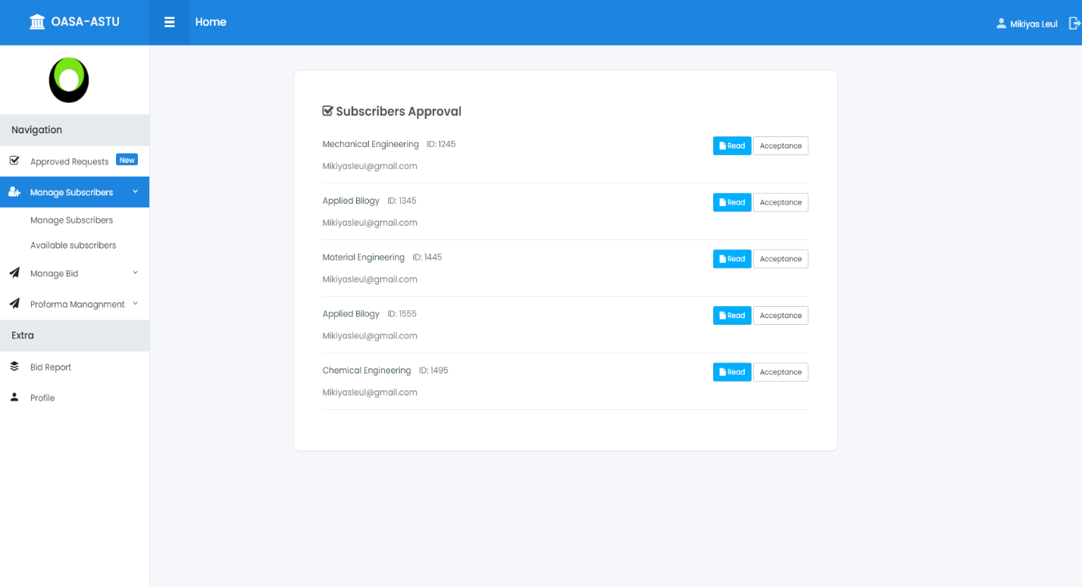

# Main page

Main page is the home page for Employees and requestors use it to get into the system and make purchase requests. Users come to this page directly from the login and when they log-out the page redirects them to the login-page.

Figure 29 User manual main-page

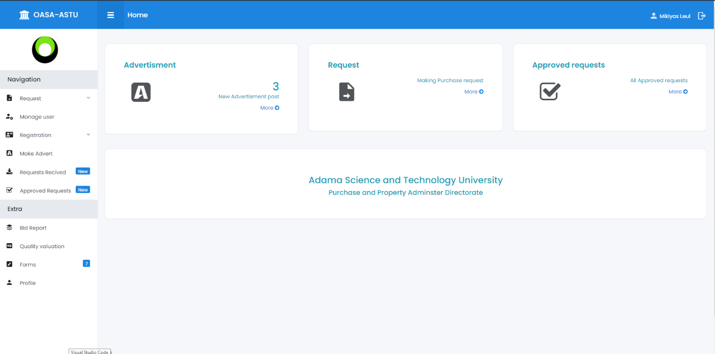

# Request

Requestioners use this page to make a request, by selecting their directorate name (department), request type, title for the request and finally they attach the request document (.pdf file).

Figure 30 User manual request

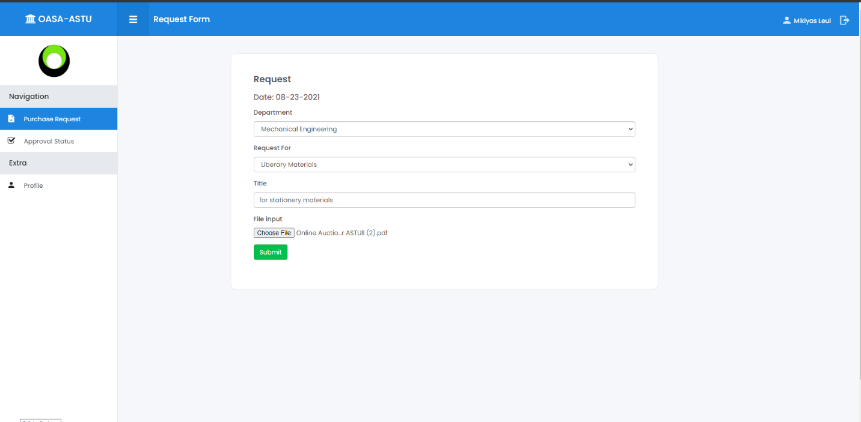

Purchase status displayed here. After the purchase request the status will say **“pending”** and they can even cancel the request that they made. When the PPAD approved their request, the status changed to **“accepted”.**

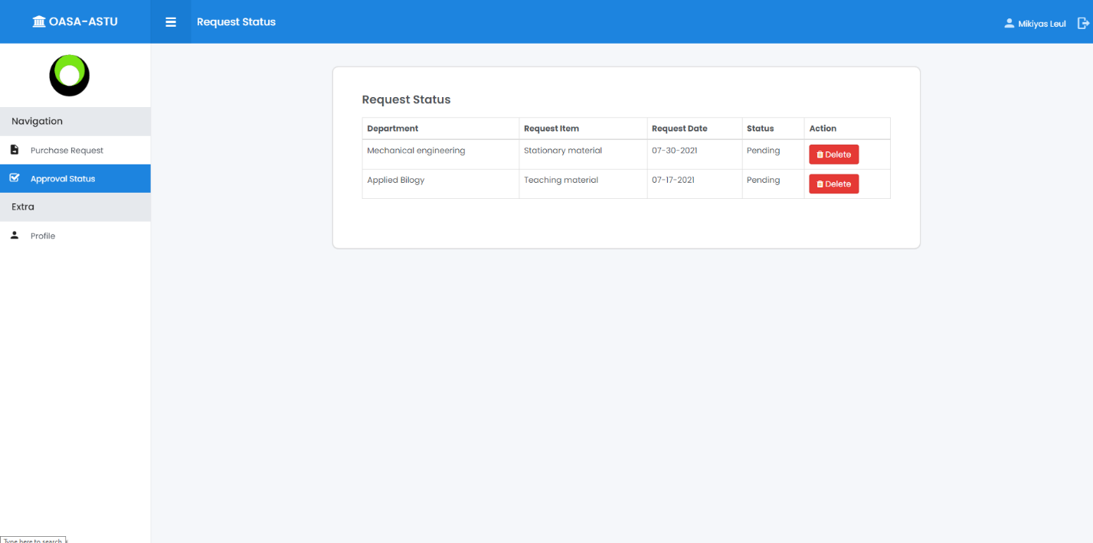

# Advertisement

After checking the approved purchase requests. Advertiser use this page to fill the necessary information and post an advert.

Figure 31 User manual advertisement

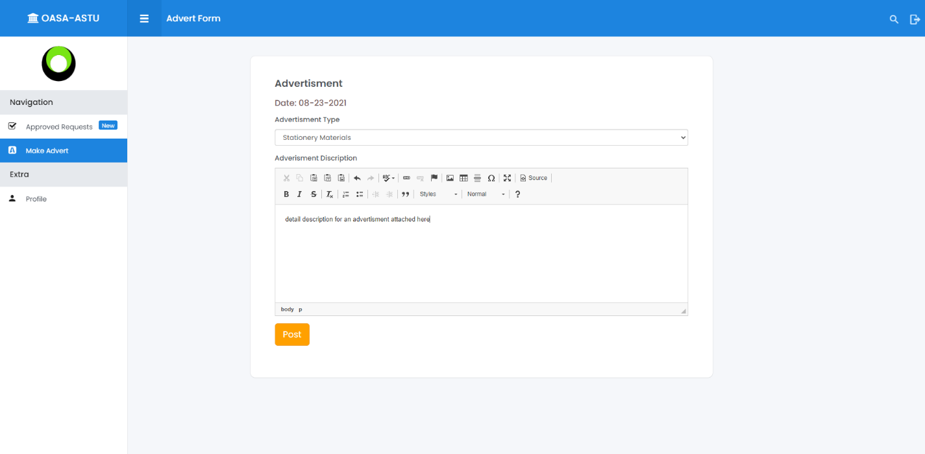

# Profile

Users can check their profile and through clicking **“Edit profile”** they can change their users-password.

Figure 32 User manual profile

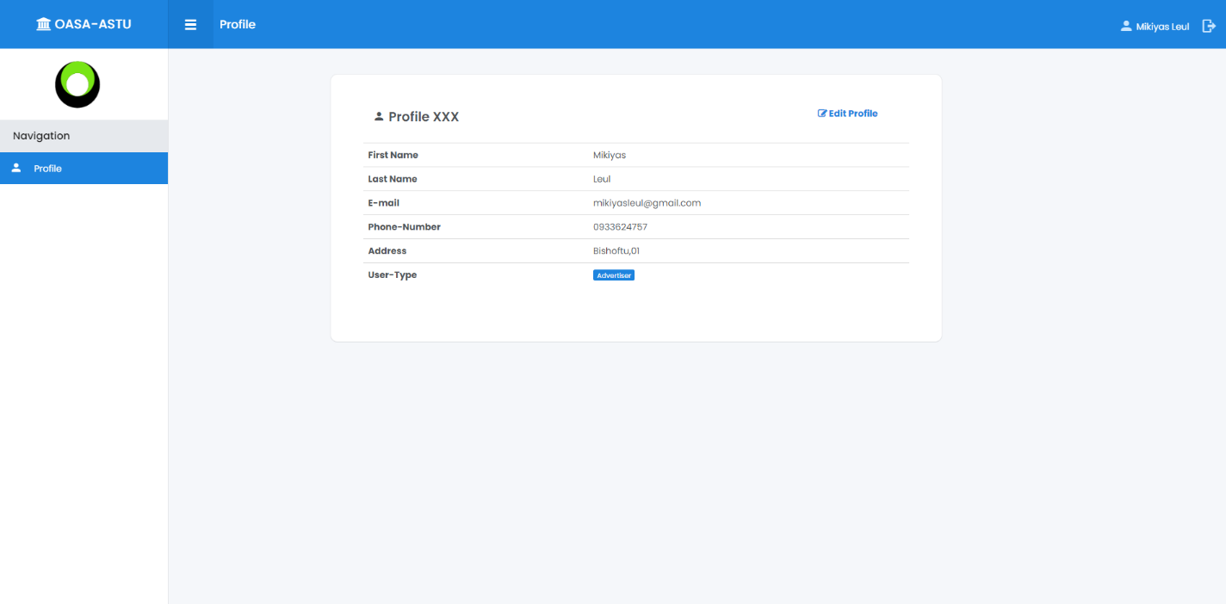

When clicking **“Edit profile”** three input fields will show up. Users can enter their old password, new password and confirm password and they can update or change their user-password.

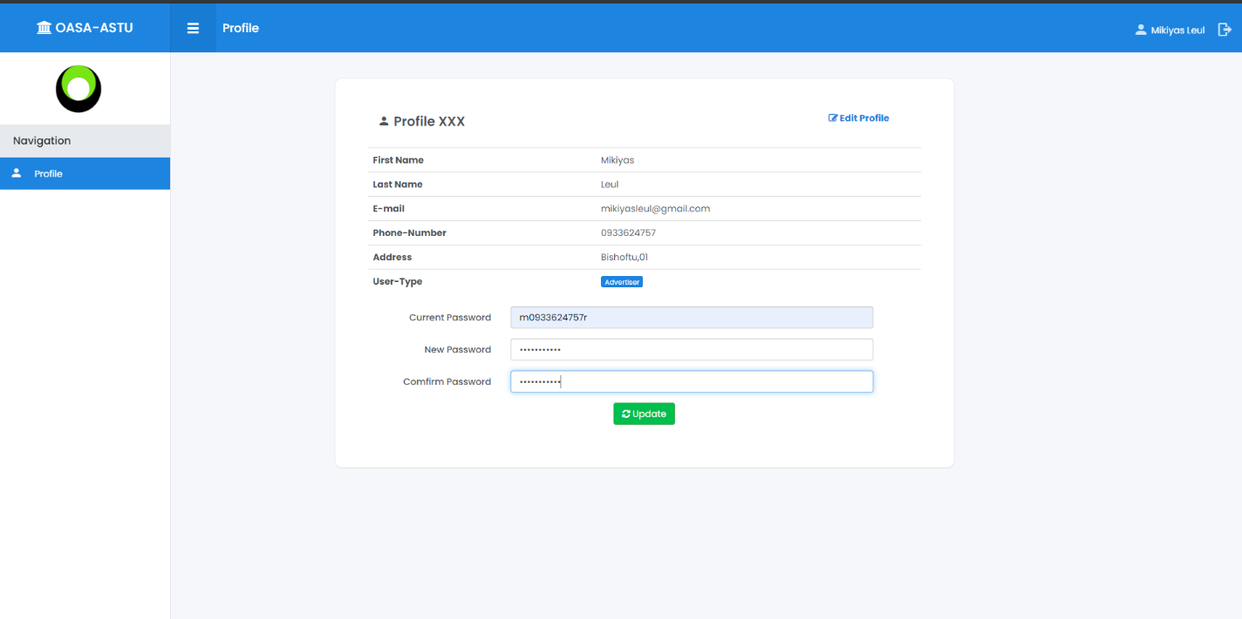

# User Registration

System admin make registration of Employer and Requestioners to the system. After this user can use their assigned user-name and user-password and log-in.

Figure 33 User manual user-registration

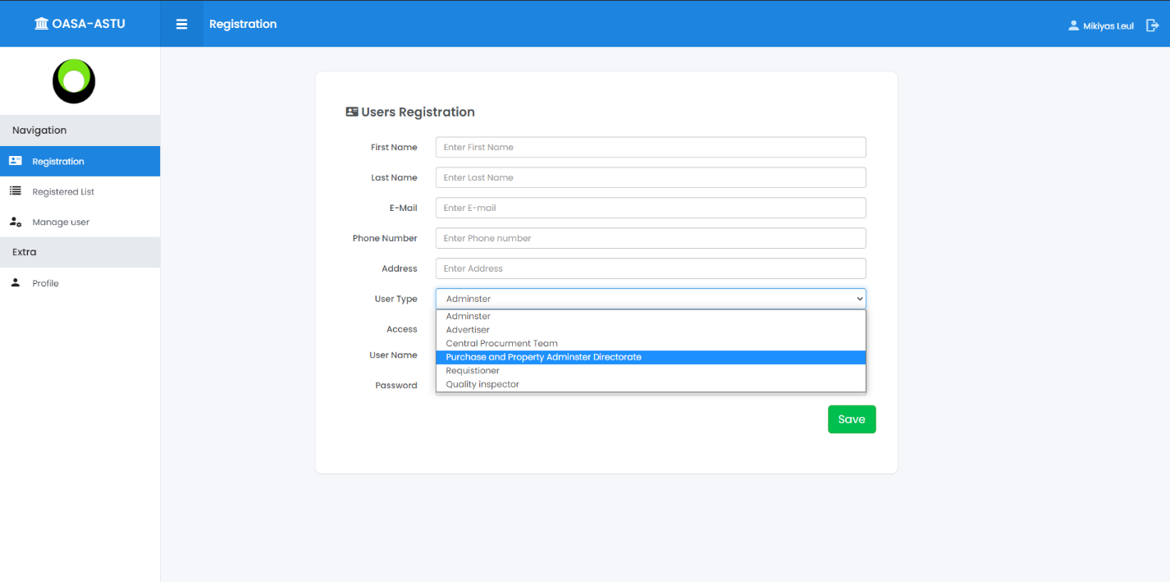

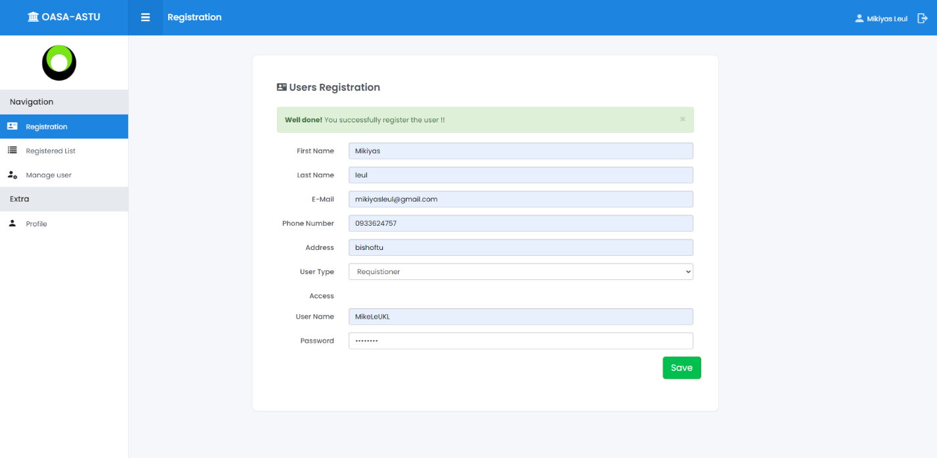

Registered users list is available, making update and cancelation of users can be done.

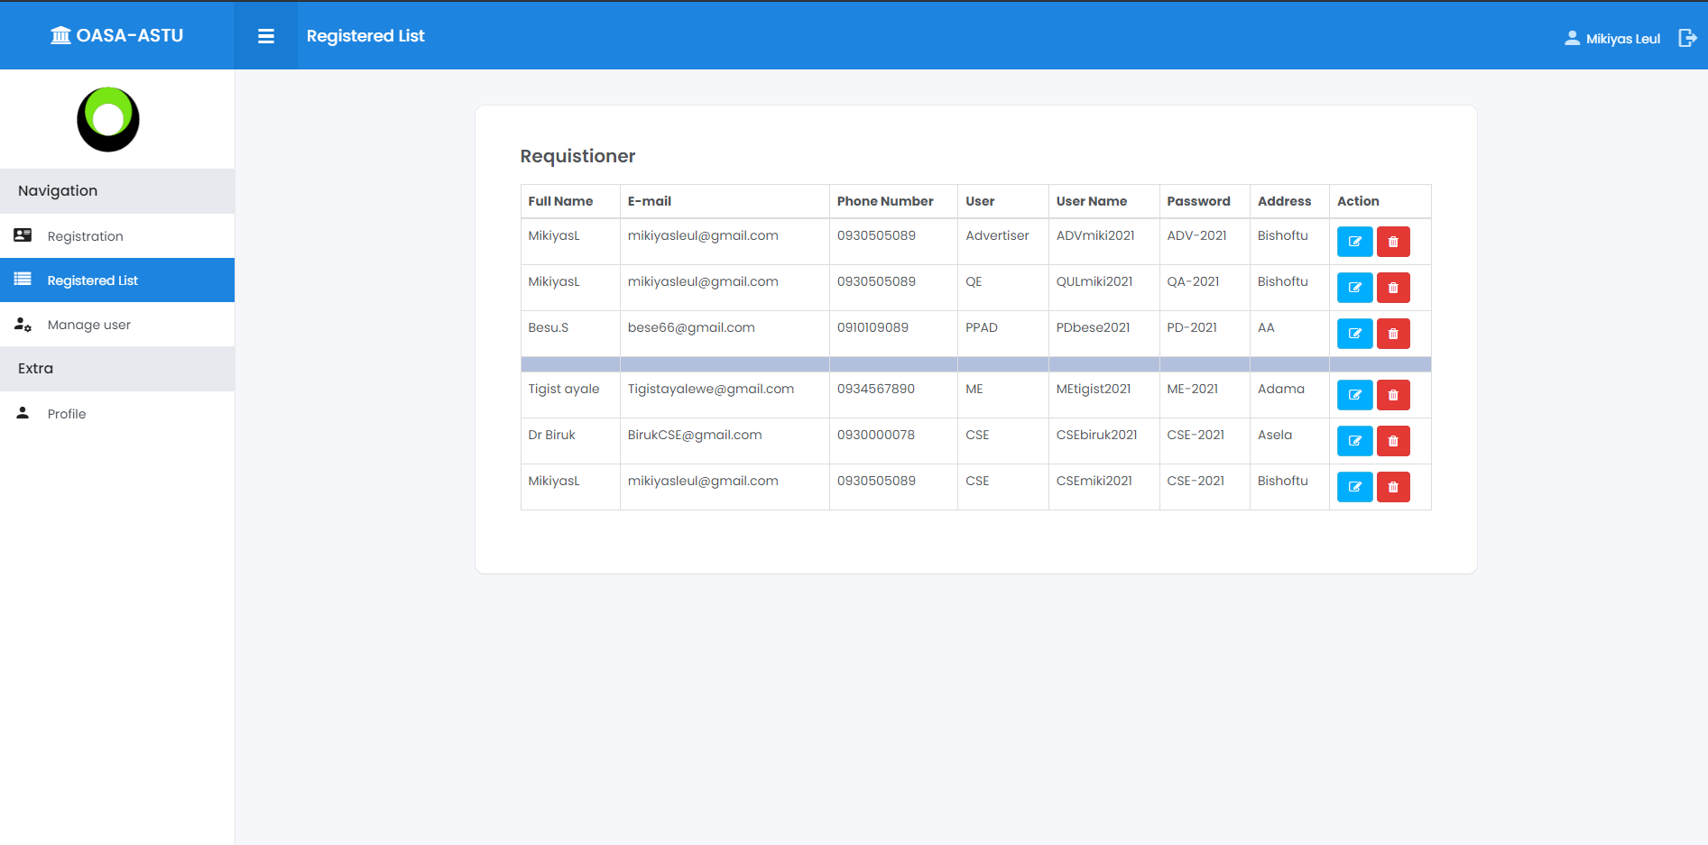

# Proforma-Purchase

Employers use this page to make a proforma request to potential companies. Information like greeting to the request, receiver’s email-address, submission link (used to make a reply for the proforma) and proforma-Document attached to the request and when send button clicked the request is made.

Figure 34 User manual proforma-purchase

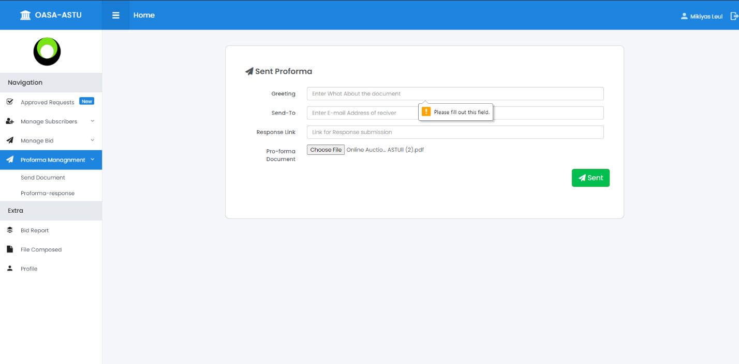

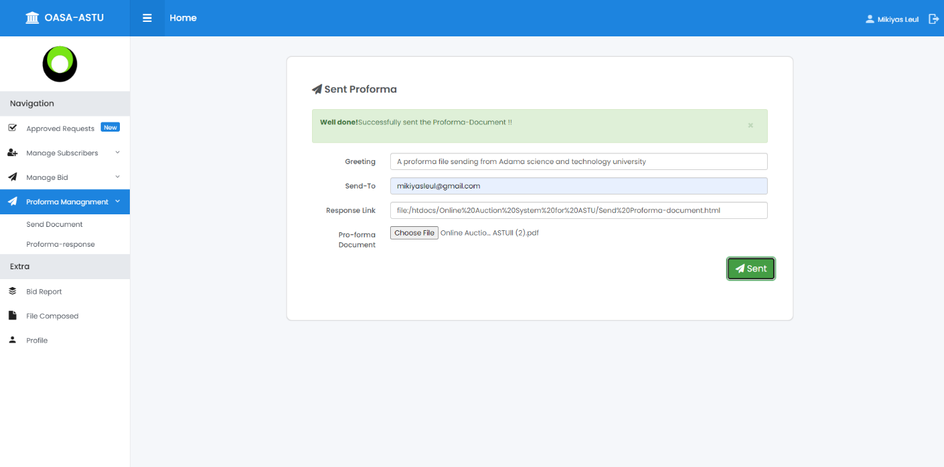

A list to proforma responders is available here. The directorate can check responders company name and for which proforma they reply.

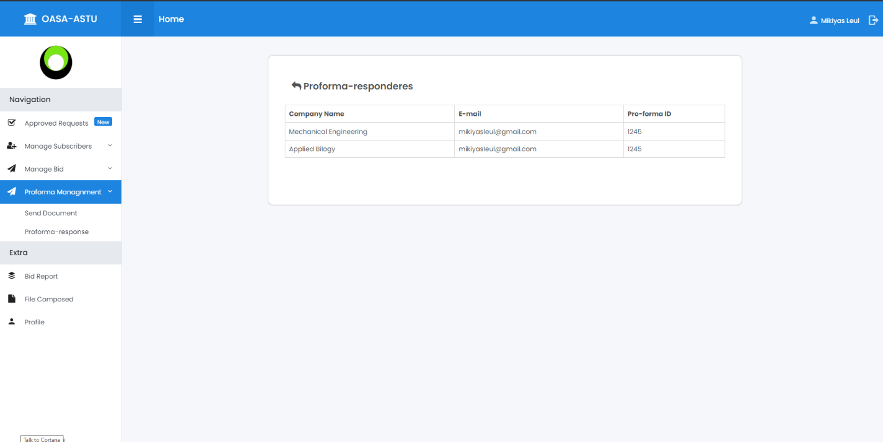

User make a reply to proforma and available bid through this page

Figure 35 User manual Bid document

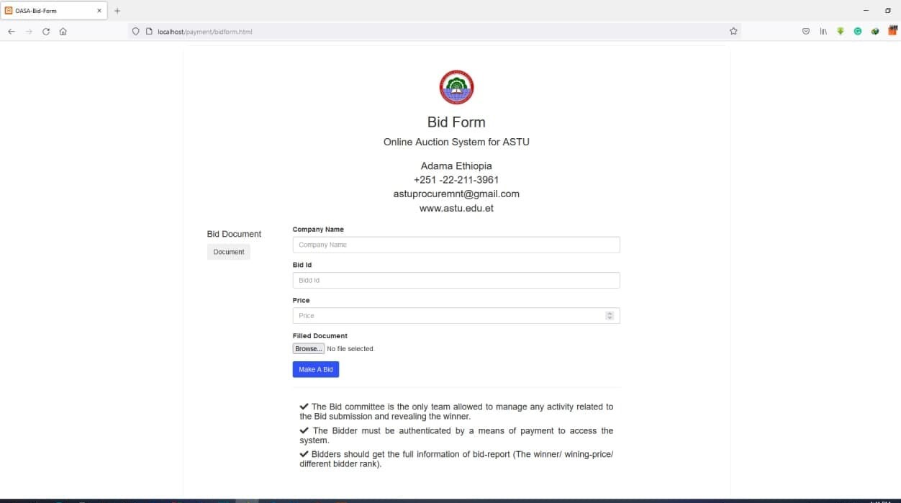

# Bid Management

Bid document attached and posted to be available for bidders.

Figure 36 User manual bid management

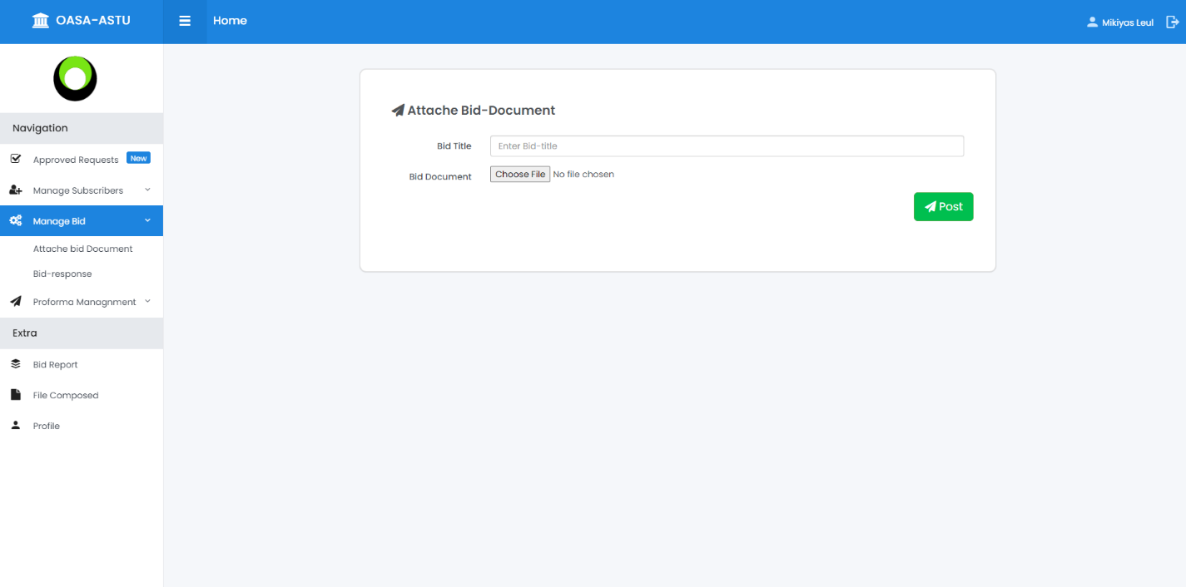

A list to bid responders is available here. The directorate can check active subscriber that participate to the specific bid made.

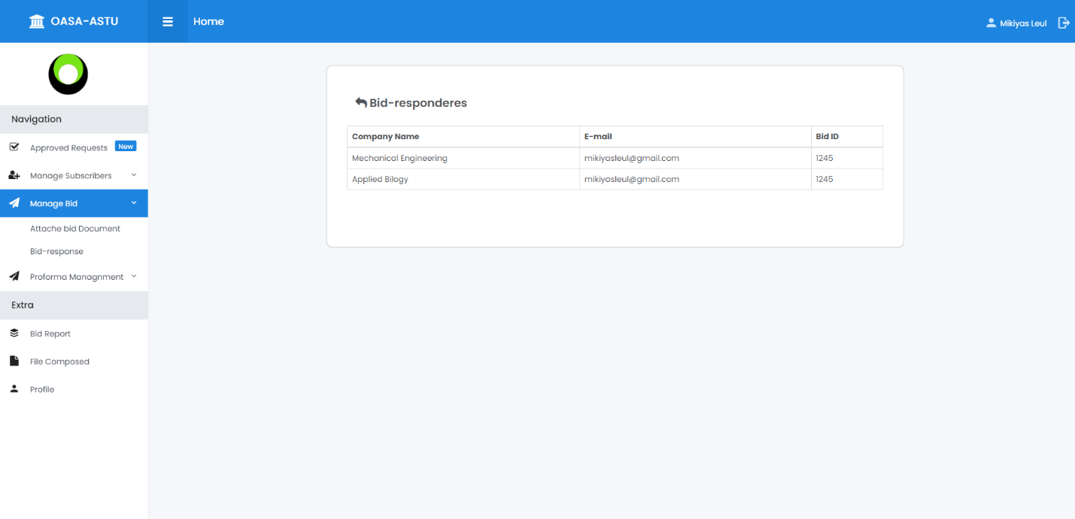

Figure 37 User manual bid report

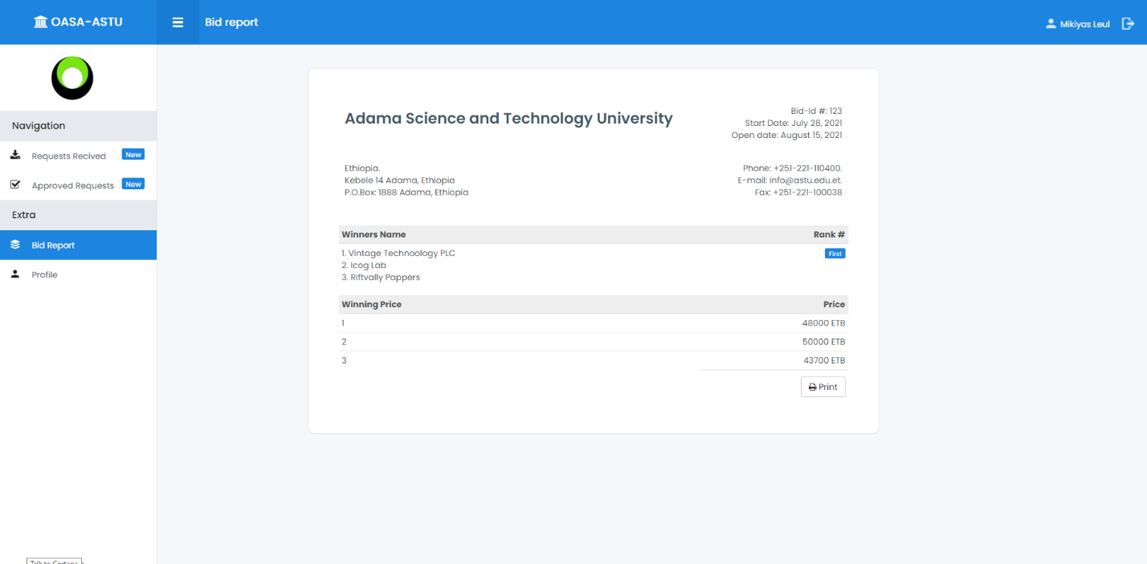

# Received request for approval

From the side bar, clicking received request will display all request made from Requestioners.

Figure 38 User manual for request approve/decline

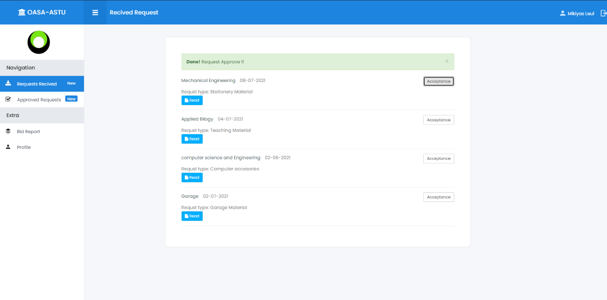

# 12. Approved Request

From the side bar, clicking approved request will display all approved request by purchase and property administer directorate.

Figure 39 Approved request

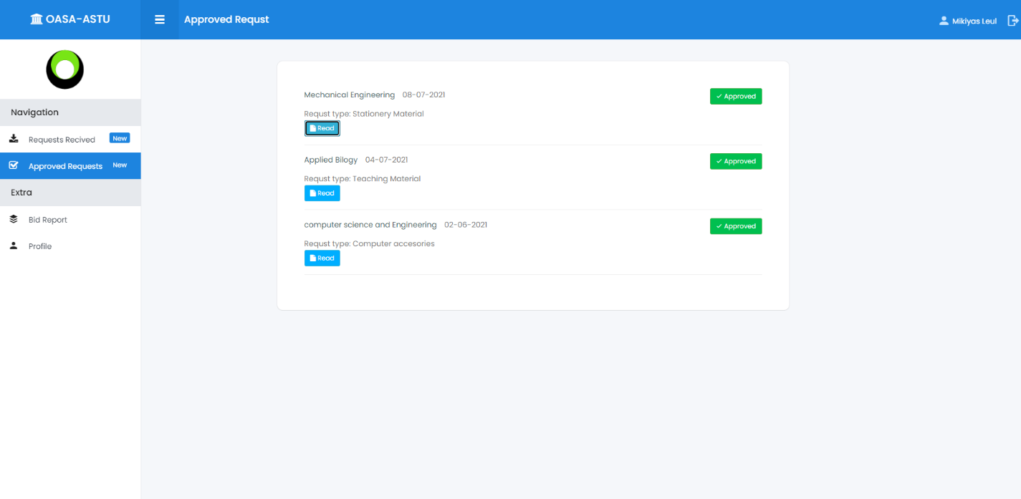

# 13.File Management

All documents to the specific purchase like request document, prepared bid document or prepared proforma document and report document will be compiled and stored together. so, when users clicked file management from the side bar the choose menu for purchase request will display.

Figure 40 File management

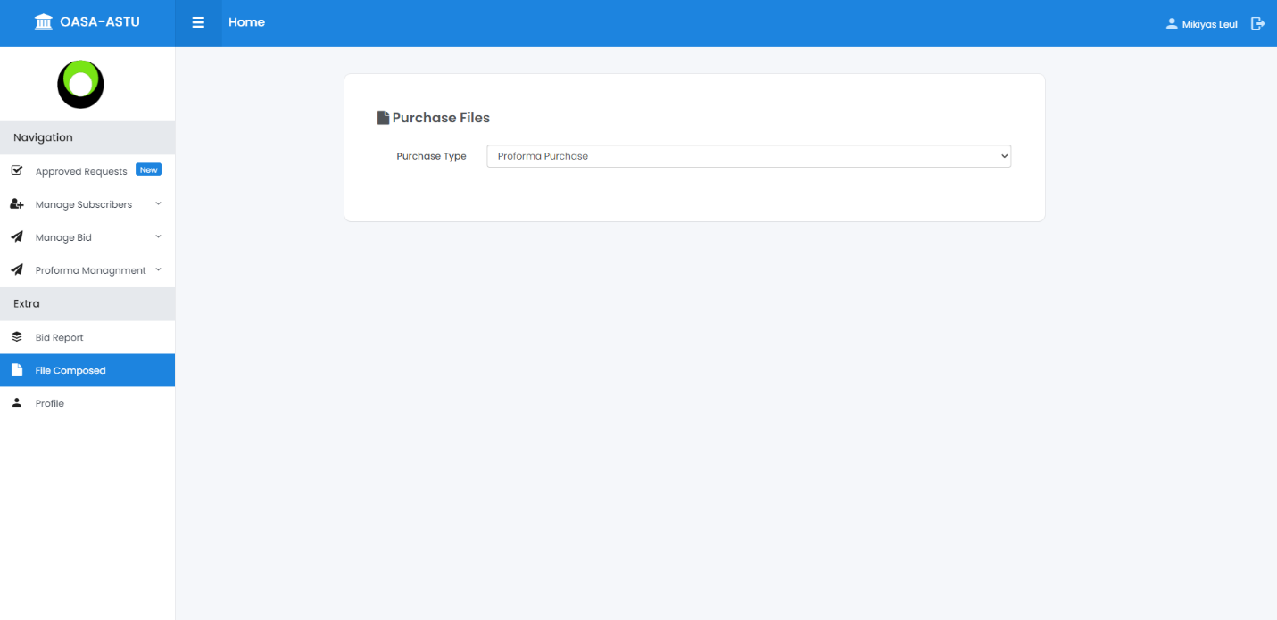

Purchase type: Bid Purchase

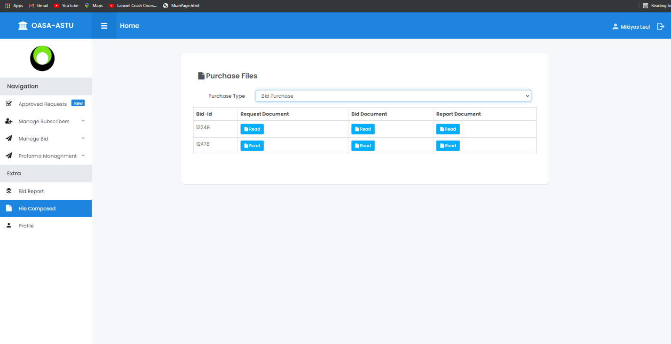

Purchase type: Prof-forma Purchase

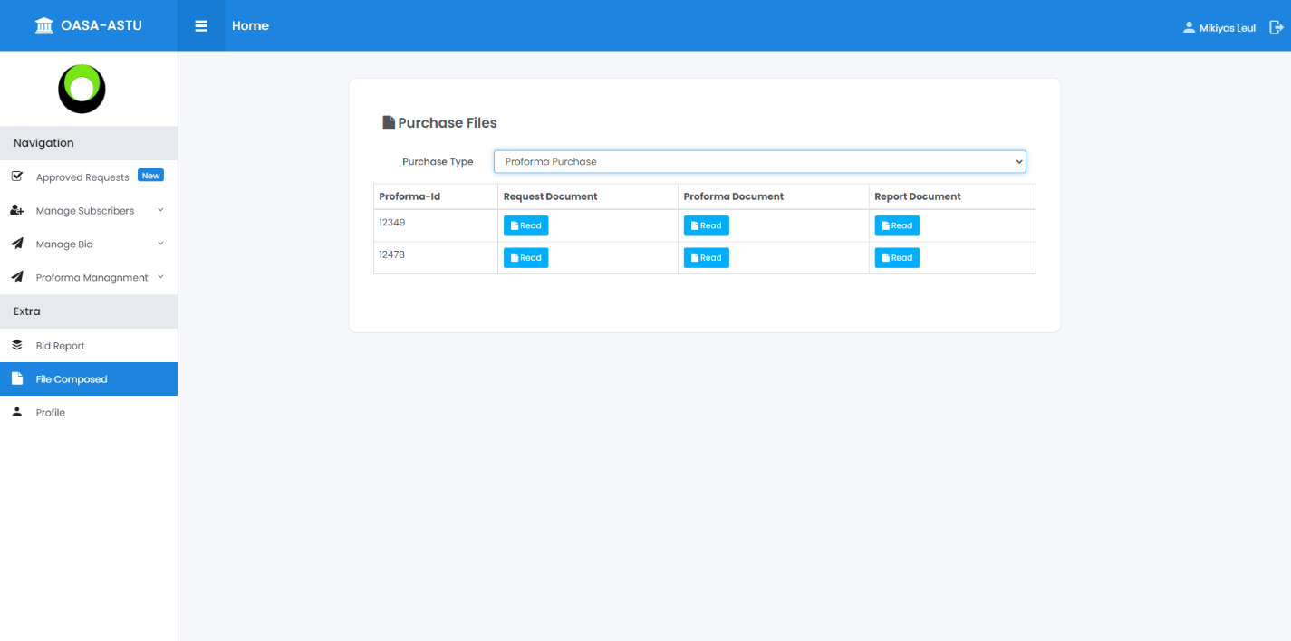

# Chapter 8

# 8.1 Conclusion

The proposed system is Online Auction System for ASTU. Its main goal is s to overcome the problems of the existing purchasing and bidding system by changing the complete current system of ASTU purchase and property administer directorate manual works into a computerized or online system without affecting the structure of the existing system.

On statement which means the use of the system defines our business plan based on the research this project we tried to lay down the problem we have conducted on the current existing systems or the current manual auctioning system. From our observations or research, we found out that there is no fully functional digitalized auctioning system developed for ASTU. So, the problem statement led to the formulation of general objective which is to design and develop an Auction System for ASTU purchase and property administer directorate, which is an interactive web-based platform that automates the current manual purchase and bidding system. This will be done by implementing the functional requirements like requisition platform, request approval and dis approval, advertisement platform, subscription module, catalog (bid form), solicitation, CRUD operation, computing bids, Announcing the winner, file management while maintaining the non-functional requirements like usability, reliability, compatibility, authenticity, security.

Among the obstacles that the system face is the limitation of requirements and limited availability of payment systems in Ethiopia and those available payment systems have few integrations with the banks. Although there are many banks only few have online payment systems. The other obstacle is the government's policy have long way to fully support the online money transaction process. There still lacks regulations to control such process, however there is still hope on the horizon as government and local banks working on it.

# 8.2 Recommendation

While developing OASA, the team and advisor has come across many challenges and tackled them one by one with mutual understanding. Owing to the experience we have accumulated while designing the proposed system (OASA) we have few suggestions to anyone who plans to work on similar project to ours. We recommend or suggest that, the other developers who wants to maintain this system to upgrade or to add features which are not covered by the system due to limitation of time or resources, should first make a maximum effort to get the full requirements from the responsible directorate, they should try to check legal code which related to Auction and bid process in Ethiopia and finally try to integrate more advanced payment platforms to the system.

# Reference

1. ASTU purchase and property administration Directorate pro-forma invoice purchasing manual,

Accessed on April 5 / 2021

1. ASTU purchase and property administration Directorate open bid process manual,

Accessed on April 5 / 2021

1. Secured sealed bid auction, <https://jis-eurasipjournals.springeropen.com>,

Accessed on April 18 / 2021

1. <https://www.investopedia.com/terms/s/sealed-bid-auction.asp>

Accessed on April 18/ 2021

1. Marches-public-afrique.com, NO. 649/2009. THE ETHIOPIAN FEDERAL GOVERNMENT PROCUREMENT AND PROPERTY ADMINISTRATION PROCLAMATION - 9 September 2009

Accessed on May 20 / 2021

1. Coding standard and guideline, <https://www.geeksforgeeks.org/coding-standards-and-guidelines>

Accessed on April17/2021

1. Yenepay payment integration, https://www.yenepay.com/Developer

Accessed on July 20 / 2021

1. Yenepay payment integration code, <https://github.com/yenepay>

Accessed on August 20 / 2021